Child interest:

Next step:

Here is a bubble finger play song

Muffin tray ball sorting (smooth, bumpy, squishy)

Where is Baby Mickey's Red Ball? (story book)

Musical instruments (Learning to listen)

The ball is going down the slide Ready, Steady, Go

(pushing balls down the slide)

Build a tower up,up,up (Blocks play)

Hammerig time !

**C&L**

Ball name game! (Monday to Friday)

Ball pit (Monday to Friday)

Ball drop and post

Obstacle courses( playing and exploring;

be willing to have ago)

home corner play (cooking with pasta)

Incy Wincy Spider story book

**PSED**

**Week**

**18th and 25/10/2021**

**Fun with bubbles/Halloween**

Bubbly Ball pit (Monday 1)

Transporting balls (Monday to Friday)

Bubble painting (Tuesday 1)

Bubble wrap printing (Wednesday 1)

Fill and pour balls using milk gallon!

Trick or treat smelly feet Halloween card (Monday 1)

Orange /black Playdough play; roll,roll and roll the dough (Tuesday 2)

Jack -O lantern sensory bin (Wednesday 2)

Hand bubbles Thursday 1

B;owing bubbles on the easel (Friday 1,2)

**PD**

**Bubbly Ball pit (Water play)!**

Implement: You’ll need a bin or container big enough to hold a few or as many balls as you desire. Balls that go in the ball pits and soapy bubbly water.

Intent: Squishing the bubbles between their fingers and dig for balls that were buried beneath the foam.  They Blow bubbles at one another…

**Bubble painting:**

* Implement: You will need to mix: A squirt of dish soap, 15 drops of food colouring 1/2 cup of Water

Simply have the children blow, and blow and blow until they have a huge pile of bubbles.  Next press the paper gently into the bubbles allowing them to pop on the paper.  Repeat the process with as many colors as the kids want.  The end result is amazing.

Hand Bubble play:

Implement: Ingredient: • 2 1/3 cup water/ • 1 cup dishwashing liquid – • 1/2 cup glycerine

Method

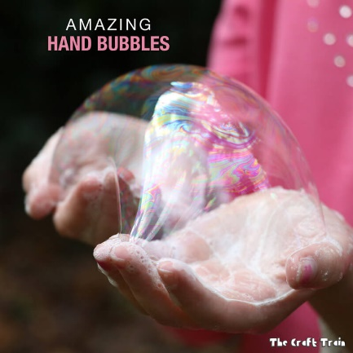Mix all ingredients together in a storage container that can be covered with a lid. Allow it to rest overnight – it will work better. Before making bubbles the next day give the mixture another good stir.

How to create hand bubbles

Dip hands into the mixture and rub together until you get a lather, then form hands into a ring shape and blow bubbles. Because you’re hands are covered in a soapy lather the bubbles will stick to them without popping and they can be distorted and passed from hand to hand. The extra glycerine in this recipe causes the bubbles to be stronger and longer lasting than usual bubbles, but if you attempt to catch them with non-soapy hands they will still burst.

**Hammer Time!**

Implement: Tape bubble wrap on the floor,  Provide children with plastic or wood hammers (such as those used with play dough) for them to pop the bubbles! (Listening and attention)

**Transporting Ball**

**Implement**: Provide trucks/balls that fit in the trucks. The children will figure out how to transport the balls to the different parts of the room!

**Ball Name Game**

**Intent:** small group games/ Circle Time is such a great time for children to learn the social skills of being together and form friendships.

**Implement:** Sit in a circle.  Name a child's name and roll the ball to that child.  Only that child should reach for the ball, then names a friend's name and rolls the ball to them.

**Here Is A Bubble** (Finger play)

Here is a bubble (make a circle using your thumb and index finger).

And here's a bubble (make larger circle using both thumbs and index fingers).

And here is  great big bubble I see.  (make a large circle using your arms).

Let's count the bubbles we've made.

One, two, three (repeat the previous actions as you count).

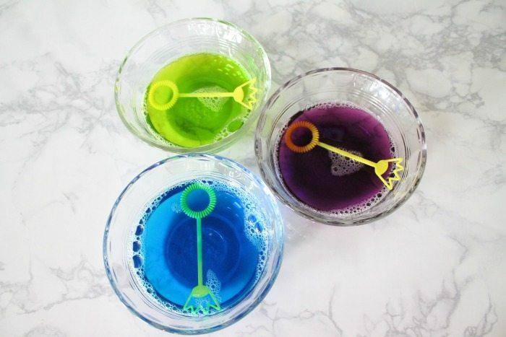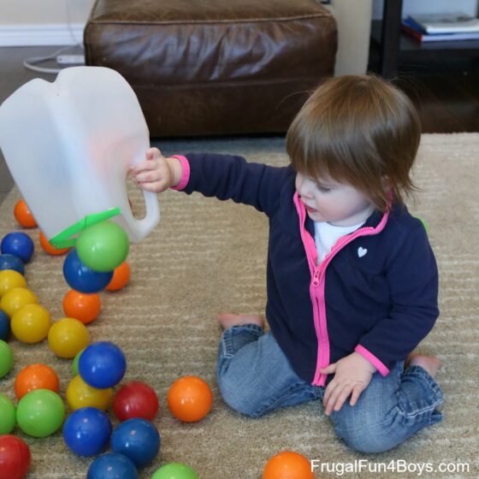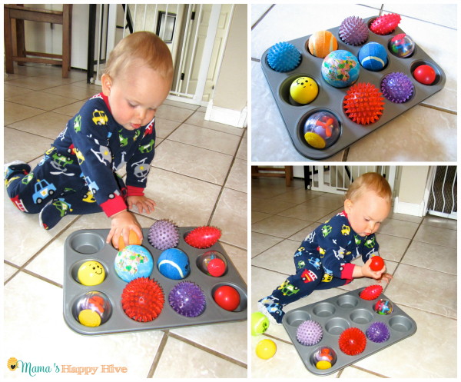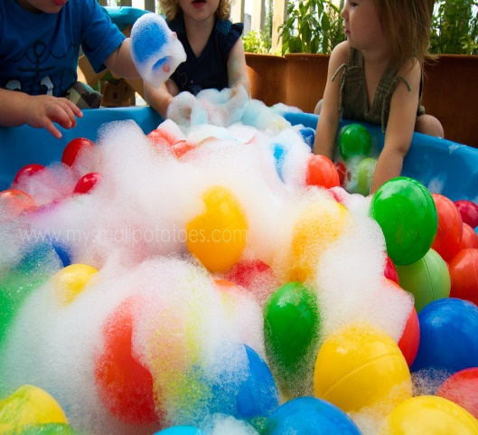Bubbly ball pit Muffin tray ball sorting Fill and pour balls Bubble painting

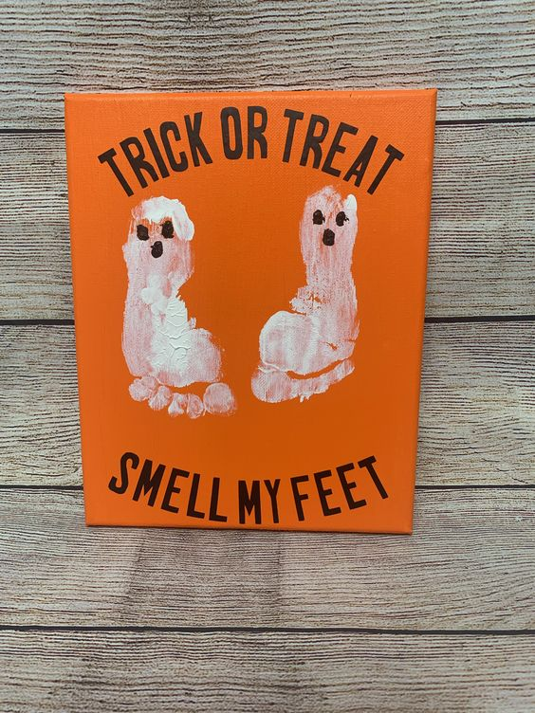Bubble wrap printing Jack-O-Lantern sensory bin

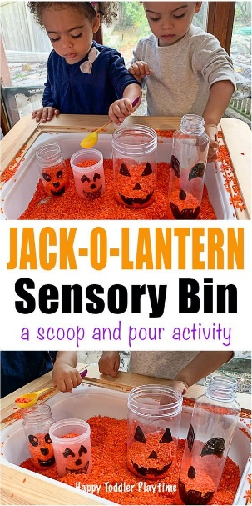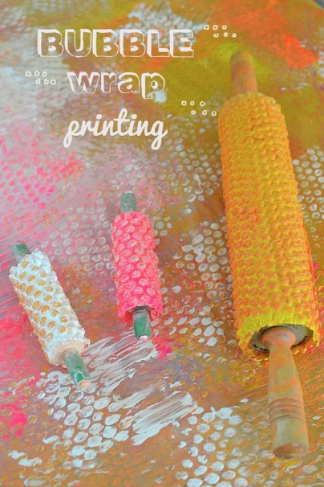

**Muffin tray ball sorting!**

**Intent:** Let the child play and sort balls of different texture and

size such as smooth, bumpy, squishy, koosh or foam to encourage sensory development.

**Obstacle Course (if child crawling e.g Jonas)**

**Implement:** For This Obstacle Course You Will Need:

* cushions and or pillows/soft steps
* [balls](https://www.amazon.com/KONIG-KIDS-BPA-Free-Textured-Multi-Shape/dp/B07BR72D7N/ref=sxin_7?ascsubtag=amzn1.osa.2dea0622-caef-438c-ac35-1efd91b4187c.ATVPDKIKX0DER.en_US&creativeASIN=B07BR72D7N&crid=34NJST86R0QXY&cv_ct_cx=infant+balls+toys&cv_ct_id=amzn1.osa.2dea0622-caef-438c-ac35-1efd91b4187c.ATVPDKIKX0DER.en_US&cv_ct_pg=search&cv_ct_wn=osp-single-source&dchild=1&keywords=infant+balls+toys&linkCode=oas&pd_rd_i=B07BR72D7N&pd_rd_r=96b341b0-6cbf-406c-b293-9ff507f56626&pd_rd_w=zAphC&pd_rd_wg=1OFFB&pf_rd_p=08a788f8-ae54-4b96-9e48-f1e694ec6c4f&pf_rd_r=ZPQXHT38RXFYC2JECVTM&qid=1596684251&sprefix=infant+balls%2Caps%2C174&sr=1-3-72d6bf18-a4db-4490-a794-9cd9552ac58d&tag=scripps-spellingbee-20) (small enough for child to lift)

**intent: create a physical challenge/ create a level of risk and children can learn by trial and error the quickest and easiest Way to go through the obstacle**

musical instruments (Learning to listen)

**implement:**

1 face the child with some musical instruments between you.

2.Play one gently.

3. describe the noises “Ding-a-ling-a-ling” or “That’s a good noise”

4.watch the child-which did they like best? Play it again.

5. Try different noise makers (bells, rattles, drums, shakers, saucepans, and wooden spoons)

6.Comment “Wow, that’s loud”, “That’s a nice noise”