Seashell cup game .

Transition “bear dressing up”

Robots move

Robot Simon Says

**PSED**

what’s missing game

Robbot puppet discussion

**C&L**

Child interest: A.P Robots/nuts, bolts

**Numeracy**

**Literacy**

**PD**

Next step:

Wind it up!

**Week**

**16/ 08/2021**

**23/08/2021**

**Robots**

Legos play; make a robot

Robots move

Garden jobs; Check plants

daily and water them

Water tray; pouring and

transferring using

container

Robot Simon Says?

**KDW**

Gear Painting (Monday 1)

Tube Bots (Tuesday 1)

Bolt and screws painting (Tuesday 2)

Losse parts robots (Wednesday 1)

Sponge painted shaped robots (Wednesday 2)

Foil Bots building (Monday 2)

Junk modeling (Friday 1,2)

Big box robot (Thursday 1

Playdough (Thursday 2)

5 Crazy robots poem

Sand paper numerlas

Shell sorting

Prewriting using robots

Tree bark rubbings

R sound box

**EAD**

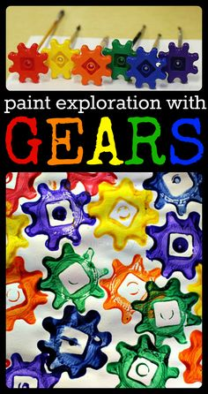**Gear Painting**

Materials Needed: Plastic gears and paint.

Implement: Place a pencil in the hole of the gears. The children press the gear into paint (that is in shallow trays) and press them onto paper, much like stamping.

**Bolt & Screw Painting**

Materials needed: Actual screws and bolts, a shallow tray or box cover, thinned paint,

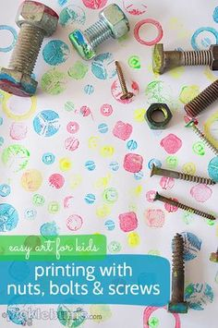paper, pipettes

**Implement**: The children place the paper in the tray and then use the pipettes to drop different colours of

paint on many areas of the paper.

Drop in a couple of bolts and screws and shake the tray left to right, front to back to paint!

**Tube-Bots**

Materials needed: cardboard tubes (paper towel, toilet paper, gift wrap tubes), pipe

cleaners, aluminum foil, miscellaneous arts & crafts supplies, markers.

The children cover the tube with foil. They then use markers and other items to decorate.

**Loose Parts Robots**

Materials needed: old CDs, milk caps, egg cartons, and any other recycled items you have,

glue.

**Implement**: The children create their own robots using the loose parts.

**Foil Bot Buildings**

**Implement**: Put boxes of aluminum foil and let the children have at it!

Provide markers as well! We have seen some pretty incredible buildings, robots and more from

the children with just the use of these 2 items!

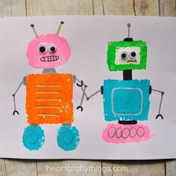Ask parents to donate some aluminum foil.

**Sponge robots**

**Robot Puppet Discussion (circle time)**

What exactly ARE Robots anyway?

Hang a large piece of paper up and have a marker ready!

Bring your favourite puppet to Circle Time to discuss Robots. Even better, MAKE a robot puppet using everyday items (such as a paper towel tube, milk caps, etc.). Use the puppet to encourage the children to talk about robots. Write down their responses.

Some discussion starters are:

What IS a robot?

Have you ever seen one? If so, where?

Do you have one in your house?

Can you make a robot? What would you need?

What makes a robot work?

How does a robot know what to do?

Have the puppet tell them that IT is a robot!

**Wind It Up!**

Provide as many different wind-up toys as you can find! Also, ask around! Ask families to provide any they are looking to get rid of!

Let the children help wind them up and watch them! They are fun to use! As they are moving, hopping, squeaking around, ask the children how they work? What makes them move, hop, or squeak?

**Extension**: Offer to provide small screwdrivers for the children to take some apart or take one apart at circle to show them!

**Big Box Robot**

Place a large box, Create a door and a couple of windows. From there, just let your children decide how to decorate this as a robot or spaceship this week.

Provide miscellaneous arts and crafts and glue or glue sticks, paper, markers, etc. The transformation throughout your theme will be awesome!

**Robot Moves**

Ask children how they think robots move?

Play different tempos of music and encourage them to move like robots to the beat!

**Robot (Simon) Says**

Encourage children to use robotic voices! Each child takes a turn suggesting a form of movement such as:

“Robot Cheryl says move your arms up and down”. Then the other children copy. remember whether or not Simon “says” or not!

|  |  |  |
| --- | --- | --- |
| 5 Crazy Robots  Create 5 flannel robots and have children take turns putting them on as they repeat the poem  with you.  5 noisy robots in the toy shop,  Shiny and tall with antennae on the top.  Along came a girl with a penny one day.  Bought a noisy robot and took it away.  (continue with 4, 3, 2, 1 noisy robots) | I’m A Little Robot  (sung to I’m A Little Teapot)  I’m a little robot, short and strong, (squat and then flex muscles)  Here are my handles, just turn me on. (put fists on hips for handles, then push belly “button”)  When I get all warmed up, watch me go. (walk fast around circle area)  Sometimes fast, sometimes slow. (march in place fast and then slow) | **Books**  Teddy and the Robot  Harry and the Robots  Greg and Steve have An Adventure in Space song on their On The Move CD and there are many others! Check out Amazon or your local library! You will use these CDs all year! |

Top of Form

|  |  |  |
| --- | --- | --- |
|  |  |  |
|  |  |  |

|  |  |  |
| --- | --- | --- |
|  |  |  |

Bottom of Form