Next step: - Place objects in, on and under on request.( CL, Understanding) ZC/YL

- Point to picture of common objects described by it use ( CL, Understanding)

Fairy tales sand play

Goldilock and 3 bears Filling and eptying water tray /big small

(Being willing to have a go)

Musical instruments/ Noisy play Soldiers (Playing and exploring)

(circle time/ Monday to Friday)

One to one reading (Listening and attention )

Blocks play

Hide and seek a sound (Listening and attention) AG/Ks/JJ

Posting boxes (building sentences) Ks/ IK

**C&L**

**PSED**

**Week 02/08 & 09/08**

**Fairy tales**

**Venus**

**Castle hand print (** (Monday1)

Magic wand craft (Tuesday 1)

(Wednesday 1)

Fairy dough play/ Easel painting (Thursday 1)

Cinderella shoe craft (Monday 2)

**Crown craft (**Tuesday 2)

Fairy castle (Wednesday 2)

Easel water painting /Playdough (Thursday 2)

Junk modelling (Friday 1,2)

**PD**

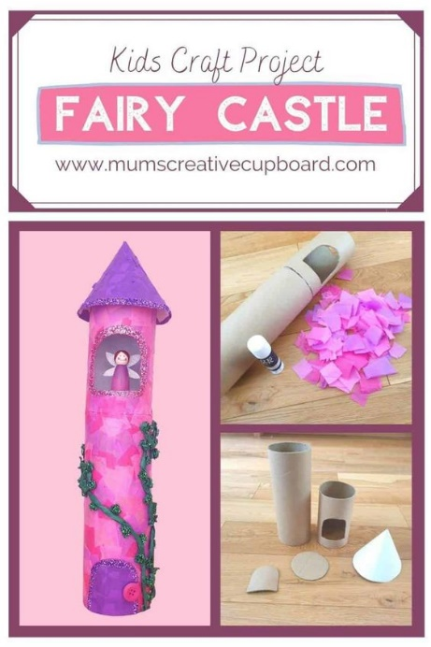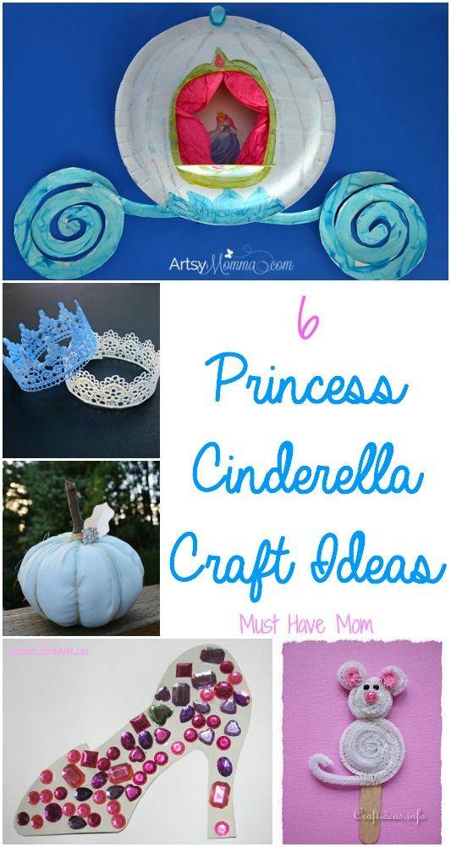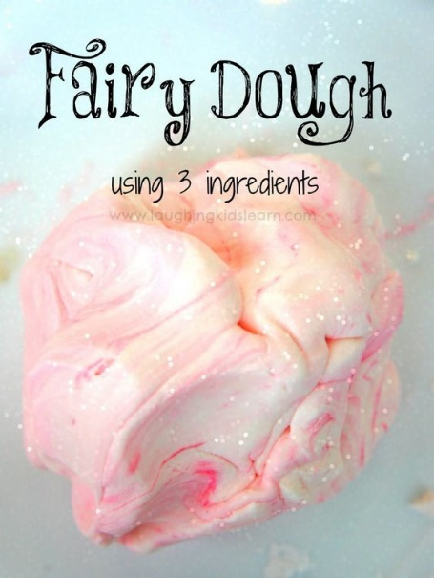 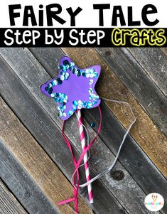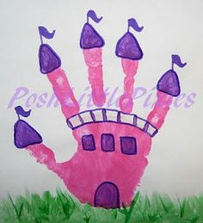

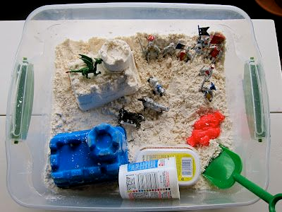

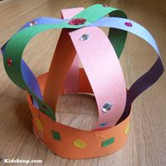

**GROSS MOTOR ACTIVITIES**

**CROSS THE BRIDGE**

**Intent** : Practice getting across a bridge in different ways.

**Implement**: Use a jump rope or a balance beam--or blocks, paper, whatever you like! to represent a bridge. Have the children practice different ways to get over it: Step on it/ Jump over it/ Step over it/ Step over it walking backwards.

**Hide and seek a sound**: (Listening and attention)

**Implement**: choose a favourite musical toy, or use an alarm cock (start with a toy that makes a loud noise and move on to a toy with a quitter sound)

Hide the toy in a fairly obvious place in the room. Encourage the child to find the toy by listening to its noise.

Say “ Listen, can you hear the noise?” “Where Is it?”

Play it a different way: Hide yourself in the room with the toy. Star the noise of the toy and ask the child to come in and find you and the noise toy. (two adults needed for this)

**Intent** : Attention and listening to sounds to be able to recognise voice, speech sounds and early words before they can understand the meaning.

**Posting boxes:**

**Implement:** You will need a card box with a hole cut out of it, that you can post pictures or objects through. Lay all the objects out and ask the infant/ toddler “which one shall we post?” They need to tll you which one can be posted before it goes in.

If the child is pointing rather than using word , give them a choice “shall we post the telephone or the cup?”

Make a big fuss when the object is posted, “look its gone! “ We posted the cup”

Intent: being able to put words together, get their message across more easily / reduce frustration communicate wants and needs.

|  |  |
| --- | --- |
| What’s in the bag songs and props . | Books  Princess Poppy –  The Fair Day Ball  Little red riding hood |

.