Child interest: animal/water /book

Home croner play;picnic

story book (Being involved and concentrating) Old Mc Donal had a farm

Musical Instruments (Playing and exploring/ Listening nd attention)

Surprise bag (learning and undersanding new wrds)

Animal puzzle

Next step:

**PSED**

**Week**

**21 and 28 /03/2022**

**On the farm /St Patricks’ Day /Mother’s Day**

**Pluto room**

Hide and seek Parachute game !

Ball pit (Monday to Friday)

Buble, buble blowing

Outdoor playing /taking risks ( playing and exploring;

be willing to have ago)

home corner play

pushchairs / baby walkers

Paper plate pig (Monday 1 )

Farm animals sensory tub (Tuesday 1)

Foot print horse (Monday 2)

Handprint sheep (Wednesday 1)

Safe mud sensory play (Tuesday 2)

Mothers day craft (Wednesday 2)

St Patricks Day craft Thursday 1/

Playdough Thursday 2

Painting on easel (Friday 1,2)

**PD**

**Funnel Spicy painting Spicy sand**

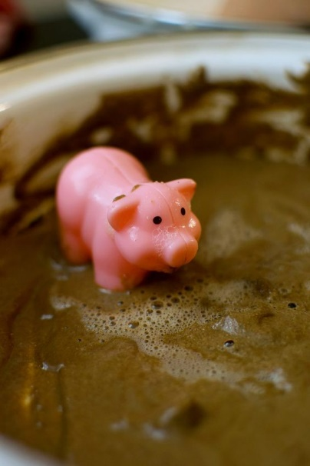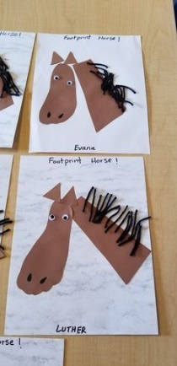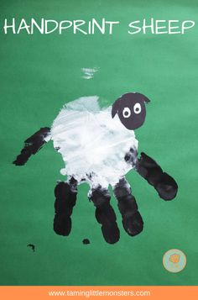

**Surprise bag:**

Intent: learning and understanding new words/ talk about the way items look, feel and sound.

Implement: put 3 or 4 objects that feel or look different in a bag, let the child pull something out tell him/her what it is, how it looks, feels and smells.

.