Jupiter/ Neptune

Eye clinic role play

I am Rosa Parks “segregation”

Shoes “poem”

.

Tap dance (sense of self )

Block play (Playing cooperatively)

Dramatic play hair saloon

**PSED**

**C&L**

Child interest:

Next step:

Take a part (Benjamin Banneker)

Fire station design

(Construction/block area)

Firefighter for a Day

**Week**

**02 / 11/2021**

**08 /11/2021**

**Fire/Bonfire night Black month history /Diwali**

Shampoo wash table (water play)

Dancing to multicultural music rythmes

Inventors; create (Monday 1)

Easel Skin shading (Tuesday 1)

Diwali craft (Wednesday 1)

Paintig frire work using straw (Thursday 1)

Easel painting (Thursday 2)

Paper diya craft (Friday 1,2)

Art traffic lights (Monday 2)

Can you hear me now? (Tuesday 2)

Shaving foam crafts (Wednesday 2)

**KDW**

Nature loose

parts counting;

leaves ,sticks ,acorns,

pinecones

Construction

I am Rosa Parks “story writing”

F is for fire tracing

L sound box

L is for light

**EAD**

**Literacy**

**Numeracy**

**PD**

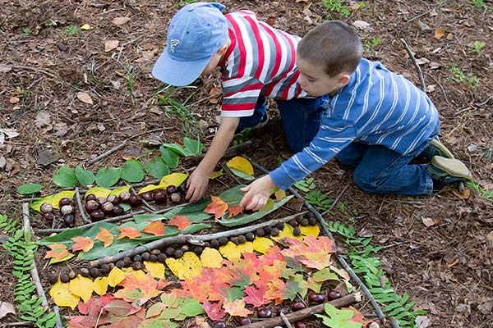**Maths Nature loose parts counting**

Create shapes using sticks. Try to make triangles that are different sizes and shapes. Challenge the children to make a hexagon or an octagon.

Bundle your sticks into piles of 10 and practice counting in groups of 10.

**Inventors:  Recycling creations**

An inventor is one who creates something new with materials.  Provide your children with items you don't use or don't use often such as recycled boxes, containers, miscellaneous arts & crafts supplies and some glue. Just let them create!

**Easel Idea-Skin Shading Colours**

Provide Black, brown, red and white paint.  The children will find that they can create any skin shade using these colours.

**Benjamin Banneker Black History Month Theme Inventor**

Mr. Banneker has, by far, been the most fascinating black inventor to research.  He invented many things including the first clock and the first Farmers' Almanac!

He was fascinated with a watch he was given as a child.  He took that watch apart and put it back together over and over again, learning about every single piece that made it work.  He took that knowledge and decided to create a large watch-a clock!  It took him 2 years but he created it.  This first clock invented by him kept PERFECT time for 30 years!

His family had experience in growing crops and farming.  Later in his own life, he put that knowledge to work. He decided to grow crops to help feed the American troops during the Revolutionary War.  During this time of crop growing, he became fascinated with Astronomy.  Someone gave him a book.  He read this book and anything else he could find on astronomy and developed what would be the first almanac.  This almanac predicted weather patterns and such.

Still later in life, he was on the team which mapped out the Federal Territory purchase!  The original member of the team who mapped out the territory left the team and with it took the blueprints everyone worked so hard on. Mr. Banneker had such an amazing memory, he was able to recreate these blueprints FROM MEMORY!

**Dr. Patricia Bath Black History Month Theme Inventor**

Dr. Patricia Bath was the first African American to receive a patent for a medical invention!  She invented the machine that allows cataracts to be treated.  It is called the Laserphaco Probe.

Eye clinic role play: Turn your dramatic play area into an eye doctor's office.  Have the children help you to create some eye charts using letters and colours.  Provide eye glass frames (no lenses in them) for the children to wear.

Provide white jackets for doctors, clipboards a couple of chairs, a table (for a desk) and other items you can think of!

**George Washington Carver Black History Month Theme Inventor**

Shaving cream was invented from a food base by George Washington Carver.  Mr. Carver is well known for his inventions from peanuts, which is why he is referred to as "The Peanut Man".  However, with all the peanut allergies, we avoid any peanut based activities.

Here is some interesting information for you:  Mr Carver also invented the following items from various food products:  Adhesives, bleach, buttermilk, instant coffee and shaving cream!  
 **Shaving Cream Fun**

Mr. Carver, as stated above, also invented adhesives.  Adhesives make things sticky!  Let's make our shaving cream sticky!

Mix equal amounts of shaving cream and white school glue.  If you want to colour it, add paint or food colouring to the shaving cream and mix.  THEN add to the glue.

Place the concoction in bowls and let the children paint on paper with it. It dries hard and somewhat shiny!

**Garret Morgan Black History Month Theme Inventor**

Mr. Morgan invented the traffic light!

**Art: Traffic Lights**

Materials needed:  red, yellow, green and orange or black paper, scissors, glue sticks

Have the children cut out large rectangles out of orange or black paper for the traffic light.

Have the children cut or tear red, yellow and green paper and glue in the appropriate area on the traffic lights.

**Rosa Parks Black History Month Theme**

Circle Time is such a great time for children to learn the social skills of being together as a large group AND to learn more about your theme!

**Segregation**

Explain to the children what segregation was (separating people by the colour of their skin).  Then decide how you will separate the children during Circle Time by attribute such as by boy or girl.  Show them what segregation is by having all children with blonde hair stand on one side and brown or black hair on another side; or by eye colour; or by who is wearing shoes and who is wearing sneakers.

**Writing Activitiy:  I Am Rosa Parks**

After reading the book, display the book at the writing center.  Provide markers or colored pencils and paper. Encourage the children to draw a picture about the story.

While they are drawing, ask them to tell you about the story and their picture.  Write down what they say to attach to their picture.

**Bill "Bojangle" Robinson Black History Month Theme**

Here are some of the accomplishments under his belt:

* He was on of the first African American performers to go solo.  Not a big deal?  Sure it was!  There was a rule in Vaudeville at the time called the "two colored rule" when performing onstage.  He overcame that!
* The movie I referred to above with Shirley Temple?  He was the FIRST African American to appear in an interracial dance team in a Hollywood film!
* He was the first African American to headline a mixed-race Broadway production.

**Tap Shoes**

Materials needed:  Different sized washers and yarn (not string).

Place a long length of yarn through a washer.

Tie the yarn to the top of the children's shoes keeping the washer at the bottom of the shoe.

Each size makes a different sound and is pretty cool!

We tried using CD's but they were too slippery and didn't make the cool sounds the washers did!

You can use these to teach rhythm, count taps and just free dance!

**Sarah "Madame" Walker Black History Month Theme Inventor**

Introduce the children to Sarah "Madame" C. J. Walker, the inventor of the pressing comb.

**Dramatic Play: Hair Salon**

Make your dramatic play area into a hair salon by providing combs, brushes, dolls with hair, chairs, foam curlers, play hair dryers (or old ones with the cords cut off), spray bottles with water, empty shampoo bottles.

**Water Table:  Shampoo Time!**

Baby dolls (with hair if you have them!), water, tear free shampoo, towels

The children learn to shampoo the dolls head/hair and dry them off.

For dolls with hair, the children can deliver them to the Dramatic Play Hair Salon when done shampooing.

**Jan Matzeliger Black History Month Theme Inventor**

Jan Mateliger was the inventor of many items which he did NOT receive credit for.  He lacked the funds and the ability to speak English to do so.  However, he took classes, learned English and patented the "shoe laster". This is a device which attached the soles of shoes to the top parts, a task that had to be done by hand by cobblers prior to his invention.

Because of this invention, it became possible for everyday people to afford shoes! (Shoes poem)

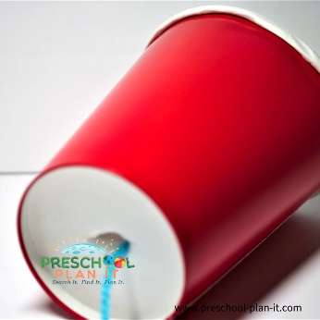**Granville Woods Black History Month Theme Inventor**

Mr. Woods invented the Telegraphony.  It was a combination of the telegraph AND voice machine.  It allowed people to use the same wire to send telegrams and messages on trains!

Can You Hear Me Now?

Provide paper cups and string or yard.

Tie off knots to the ends of 3 foot lengths of yard.  Place the knots into the bottoms of 2 paper cups.

One child places the open part of the cup to their ear.  Another child places the cup over their mouth.

If the cups are pulled so the yarn is tight, one child will hear the other child when he/she talks or sings into the cup!

**Diwali craft**

# **Colourful Diwali Paper Diya Craft**

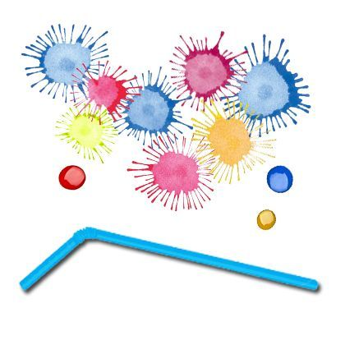

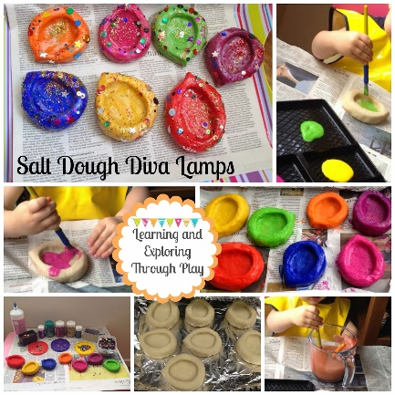**Painting Fireworks with straw**

Salt Dough Diva

Intent:

lamps are great for children. It allows them freedom to be create and express themselves, making a piece of art. They can then go on to learn about the Festival of Light, Diwali celebrated by Hindu's and Sikhs around the world.  
Make the salt dough the night before.  
**You will need:**  
1 cup of Salt  
2 cups of Plain Flour  
1 cup of water, Add to a bowl and mix well.  
  
Bake the lamps in the oven on 100 degrees for around an hour and a half. Once they were cooked I left them to cool down.  
The following day you can decorate them.

|  |  |  |
| --- | --- | --- |
| **Shoes**  Before I jump into my bed,  Before I dim the light,  I put my shoes together,  So they can talk all night.  I'm sure they would be lonesome,  If I tossed one here or there,  So I put my shoes together,  For they are a friendly pair. |  |  |