Next step: - Place objects in, on and under on request.( CL, Understanding) ZC/YL

- Point to picture of common objects described by it use ( CL, Understanding)

(circle time/ Monday to Friday)

The giving farm poem (Listening and attention)

One to one reading (Listening and attention )

Old Mc Donald had a farm book

Farm animals puppet show

Old Mc Donald had a farm small world play

Farm animals washing station

parachute game (Being willing to have a go)

Musical instruments (Playing and exploring)

**C&L**

**PSED**

**Week 04/04 & 11/04/22**

**On the farm/ Easter**

**Venus**

**(** (Monday1) Yarn collage

(Tuesday 1) butter milk painting

(Wednesday 1) Hand print chicken (Easter card)

(Thursday 1) Corn on the cob painting

(Monday 2) Feather collage

**(**Tuesday 2) Sheep collage popcorn bags

(Wednesday 2) Farm printing

(Thursday 2) Muddy pig prints

Junk modelling (Friday 1,2)

**PD**

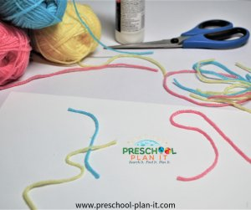

**Yarn Collage**

Provide different colours and lengths of yarn. Explain that wool yarn is made from sheep's fur! They can make some great collages by gluing the yarn on paper.

**Buttermilk Painting**

Have the children dip chalk into buttermilk and then draw on paper. This makes a great effect!

**Feather Collage**

Materials Needed: feathers, paper plates, googly eyes, paper plates, glue, strips of orange paper and scissors ( to make legs!)

**Corn on the Cob Painting**

Roll corn on the cob onto paint in shallow trays and then roll onto paper.

**Old MacDonald's small world play.**

Add tractors and small, plastic farm theme animals to the block area during this theme!

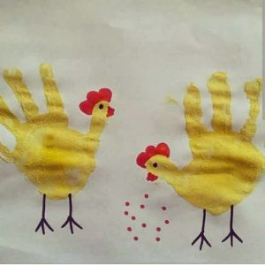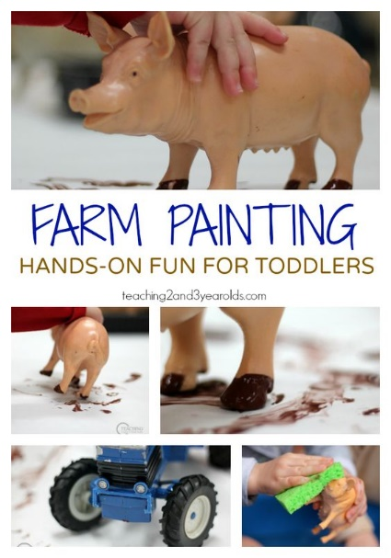

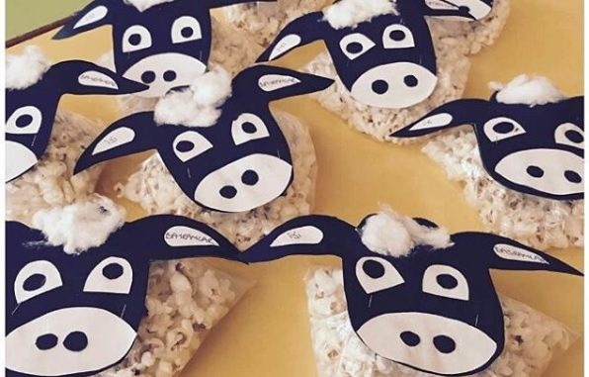 Sheep collage, popcorn bags

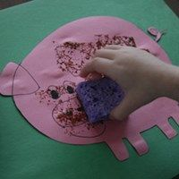

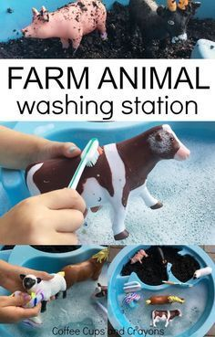

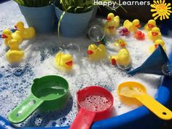

|  |  |  |
| --- | --- | --- |
| .  **Old MacDonald**  Sing this classic song with the children. Have them act out the animal you sing about and encourage them to make that animal sound! | **The Giving Farm** **Poem**  by Vicki Witcher  Hens give eggs.  Pigs give ham.  Cows give milk.  Strawberries give jam.  Bees give honey.  Goats give cheese.  Farms give food,  I'd like some, please! | **5 Clean Squeaky Pigs**  Sung to 5 Little Speckled Frogs  5 pigs so squeaky clean  Cleanest pigs you've ever seen!  Wanted to go outside and play  Oink! Oink!  One jumped into the mud  And landed with a great, big THUD!  Then there four nine clean squeaky pigs.  Oink! Oink! |

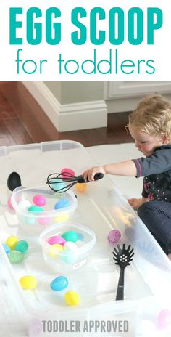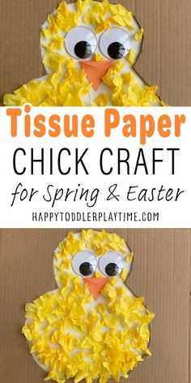**Easter Crafts**



