Jupiter/ Neptune

Apple song.

How do apples grow? Story book

The great adventure of the apple (story making)

Stop and go musical instruments (Listening and attention)

The very helpful hedgehog story book

What are mushrooms fact video (Likes and dislikes) <https://youtu.be/VJCF1d8Pjj4>

Simon says game

**PSED**

**C&L**

Child interest:

**Numeracy**

**Literacy**

Next step:

Apple investigation station

Farm animals small world play

Mushroom investigation station

Portebello mushrooms printing

(Thursday 1)

Apple tree parachute game

Playdough with fruit and

vegeatbles cutters

Lets ‘s jump (different jumping skills)

Tree climbing

Pouring and transferring

( water play)

**Week**

**27 / 09/2021**

**04/10/2021**

**Apples/Mushrooms /Harvest Festival**

**KDW**

Apple core painting (Monday)

Apple tree easel painting (Tuesday)

Seeds music maker (Wednesday)

Apple finger painting (Thursday)

Popstick apple core (Friday)

Corn on cob printing (Monday 1)

Cupcake liner mushrrom (Tuesday 1)

Musroom sticking craft (Wednesday1)

Orange pear, apple

bear story book

Apple tracing

A sound box

A is fo apple tracing

sheet

M is for mushroom

tracing

Guessing game: how many

seeds inside the apple

Apples falling 1,2,3

Apple fractions.

Apple tree; counting and

matching

Mushroom sorting

**EAD**

**PD**

**Apple investigation station:**

Set up an apple investigation station with a few varieties of apples to observe. Slice some apples into halves and quarters and provide magnifying glasses to help children look more closely at the seeds.

Set up a small world farm and discuss harvesting.

FACT about apples to discuss with the children:

Apples are fruits which are ripe and ready to be eaten in the autumn.

Apples grow on trees and start off from flowers.

Apple trees are covered in white blossom in spring.

There are five parts of an apple. The outside is the skin. The inside is the flesh. There are seeds inside of the apple. The stem is on top. Some apples have leaves by the stem.

**Apple trees need to have their flowers pollinated** if any fruits are going to develop. **Bees and butterflies are** the very important **helpers** here. As **the bees** **and butterflies** **fly from plant to plant collecting nectar to eat**, **they also take pollen from one plant to another**. When pollen arrives from another plant it fertilises the egg cells in the receiving plant, and these egg cells grow into seeds. **The seeds are protected inside a fruit**, which grow and ripen in the autumn – and **that’s the apple**!

**Apple Core Painting**

On a day that you are exploring apples, save the cores to use at the art table to paint with!

**Implement:** Provide the children with Paint, paper . Put the paint in shallow trays. Use the cores to roll in the paint and then roll or stamp onto the paper.

**Farm animals block play**

**Implement:** Add apples, leaves, eater grass and toy trucks to your block area for some apple farm fun!

**The Adventures of the Apple**

Materials: An apple, a piece of paper and a pen

Tell the children they are going to help you write a story. We named ours **the Great Apple Adventure**! Write down what each child says so that you have it for compiling the book as discussed at the end of this activity!

**Intent:** This is a cooperative story telling technique that the kids LOVE because they are allowed to make it up! Note to you as the teacher: Remember that this is THEIR story, not yours! It will most likely NOT make sense. It may have the apple being given a time out. It may have the apple visiting a hospital. Go with it...children will use make-believe to talk about things that bother them, scare them or simply things on their minds!

**Implement:** prepare the children by telling them that in our stories, we use our classroom rules (prevents too much make believe "violence" from happening). Those are the only rules. Try your best, as the teacher, not to tell them what to say next or what should happen next. Enjoy!

-This is the story of the Great Apple Adventure! Once upon a time there were some apples that lived at XXXX Preschool. They wanted to go on an adventure. They went outside and they saw....

Have one child fill in the blank.

Continue the story. "The apples saw (fill in what the child just said) and then decided to.... (next child fills in).

This is a story that the children will want you to read over and over to them at circle time!

At the writing table, remind each child what part of the story they made up and ask them to draw a picture about that one thing.

Use the pictures as the illustrations. Each page is in the order it was told, and you write the words each child said on their illustrated page.

Make color copies of the book for each child to take home!

**Guessing Game:** Materials Needed: One apple, knife and cutting board.

**Implement**: Have the children guess how many seeds might be in your apple. Cut open and remove the seeds and count them together.

**Apple Trees (Easel painting).**

**Implement:** Put red, green, yellow and brown paint at the easel. Hang pictures of apple trees around your easel to inspire your budding artists!

**Apple Tree Parachute Game**

**Implement**: Have the children all sit in a circle on their knees. Tell them they are apple seeds and they should bend forward with their cheeks on the floor but still sitting on their knees.

Place the parachute over them so their feet are sticking outside of the outer edge of the parachute.

Tell them this is the soil covering them, the seeds.

Now act out, step by step, the seeds growing into a tree.

The seeds get bigger and bigger (they wiggle backward out of the chute, staying on their knees until they are all around the chute).

The seeds are now growing more because they are getting sunlight and water (they all hold the parachute and slowly squat up then stand up).

And now the seeds have grown into trees!

Now say the Apple Tree Fingerplay Poem!

Say the Apples falling song and then shake the parachute like crazy!

**Seed Music Makers:** Materials: Small paper plates, markers or crayons, stapler, seeds.

**Implement**: The children decorate the paper plates.

Staple the plates together leaving small opening.

The children add seeds to the opening and you finish stapling it closed.

Use these as music makers for a parade, to use while dancing to music, etc.

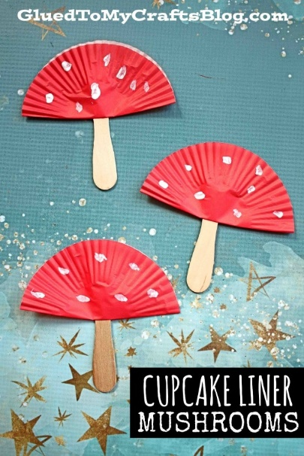Pop sticks Apple core.

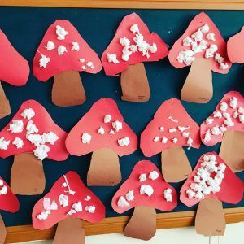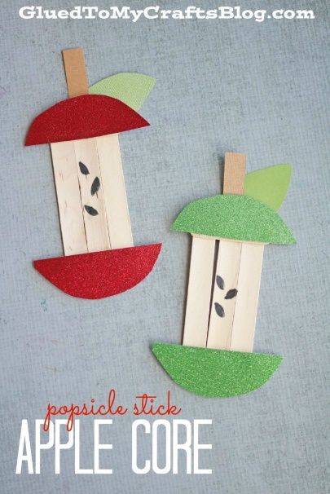

<https://www.youtube.com/watch?v=VJCF1d8Pjj4> (What are mushrooms)

|  |  |  |
| --- | --- | --- |
| **Apple Song**  Play a singing circle game to the tune of "Here We Go Round the Mulberry Bush." Children skip in a circle, holding hands, while singing the first verse.  Verse 1: Here we go round the apple tree, The apple tree, the apple tree. Here we go round the apple tree, So early in the morning.  Verse 2: This is the way we plant the seeds.  Verse 3: This is the way the little seed sprouts.  Verse 4: This is the way it grows to a tree.  Verse 5: This is the way the flowers blossom.  Verse 6: This is the way the apples grow.  Verse 7: This is the way the apples are picked. | **Apples Falling**  (Sing to Are you Sleeping).  Apples falling, apples falling  From the tree, from the tree.  Pick up all the apples. Pick up all the apples.  1,2,3 1,2,3 | **Harvest song;**  (Tune) 'Here we go round the mulberry bush':  Here's what we do at harvest time, at harvest time, at harvest time,  Here's what we do at harvest time,  At harvest time in the autumn.   Cut all the corn at harvest time....  Dig up potatoes.....  Share out our fruit......  Pick all the apples.....  Gather the blackberries.....  . |