Take pictures of your

shadow.

Trace around my shadow; self-confidence and self-awareness.

**PSED**

Shadow puppet/theatre show (outdoors)

Light box: Picture stories

Shadow Simon says game

Shadow guessing game

My shadow rhhme

The sun rhyme

**C&L**

Child interest: A.P Shadows

**Numeracy**

**Literacy**

**PD**

Next step:

**Week**

**05 / 07/2021**

**12/07/2021**

**Sunshine and Shadows /Eid El Adha**

Garden walk;

Exploring shadows

Draw around shadows

and observe changes

coloured objecs

shadows

Wooden blocks and torches play

Dance with your shadow

Gafrden jobs; Check plants

daily and water them

shadow tag!

Water tray; pouring and

transferring using

container

**KDW**

Animal shadows

Drawing (Monday 1)

Butterly silouhette craft (Tuesday 1)

Shadow scuplurtes; playdough

(Wednesday 1)

Eid Cards (Wednesday 2)

Sun sticking activity (Monday 2)

Junk modeling

(Friday 1,2)

Painting on easel

(Thursday 1,2)

Light box;

Shapes and patterns

3 D shapes shadow

Number rhymes

Sand paper numerlas

Chalk mark making

on board

Tree bark rubbings

S sound box

Sun flower colouring

S is for sun tracing

sheet

**EAD**

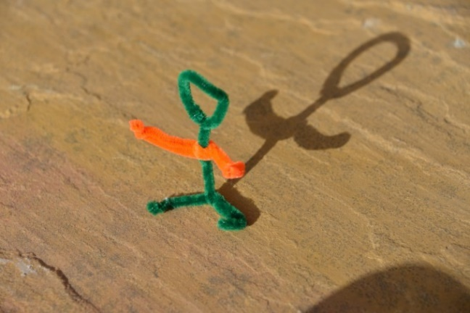**Shadow puppet Theatre show**

Investigate how we can use shadows to tell stories. Create and set up your own shadow puppet show; using children’s interest e.g. cars, animals; place them in the sun and use their shadows to tell a story, or encourage the children to make their own stories using their own imagination.

**Exploring shadows outside!** Go outside on a sunny day and talk about what you can see. What are shadows? How are these made? Can we create our own shadows? Do shadows change? Record down the children's curiosities as a starting point. You might explore shadows under a tree, shadows of objects with holes in (slotted spoons, cheese grater)

**Drawing around the shadows:**

draw around the shadows in chalk and see how these change throughout the day.

**Exploring shadows inside; wooden blocks and torches play:** adding torches to block play and see if shadows can be made of the models that are made

**Coloured objects shadows**:

Take a look at reflection by placing coloured magnatiles, cellophane or coloured blocks in the window and watching their colours reflect. Can we mix colours together? What do we predict will happen?

**Shadow Simon says** : Using whatever light source you have available, create shadows of kids’ entire bodies on the wall or outside .  Choose a leader and encourage the rest of the group to watch the leader’s shadow and follow along as he moves into and out of different positions.

**Shadow Guessing Game**

Work on [**visual perception**](https://theinspiredtreehouse.com/developmental-skills-visual-perception/) by creating shadows of various familiar objects and having kids guess what the objects are just by looking at their shadows.

**Shadow Tag** Instead of touching or tagging your opponents, in this game – if your shadow gets stepped on, you’re it!

**Facts about shadows:**

* **A shadow** follows you around in the light and say goodbye to you in the night.
* Swings, trees, cars, tables and almost everything else has a shadow. Any object – living or non-living that can block light can cast shadows.
* **Shadows are formation:** Sometimes objects can block light which means that no light is able to pass through that object. An object from which no light can pass through is called an **opaque** object. The easiest example is our body. Stand in the way of a beam of a light from a small torch. Ask someone to stand behind you and spot the beam of light. The person behind you will see no light since your body did not allow it to pass. Whenever light is not able to go through an object, it creates a dark area around the object. This patch where the light cannot reach is **called a shadow.** **Opaque** objects create clear dark shadows.
* The size of the shadow keeps changing throughout the day. It is longest in the early morning and the late afternoon. At noon when the sun is overhead there is little or no shadow at all. Why? The position of sun changes throughout the day.
* our shadow chases us? when the object is moving, the shadow moves as it is formed where all the moving object blocks light. It is that simple!
* Did you know that shadows are used to make puppets? Yes, they are, and such an art is called **Shadow Puppetry**!

**Light box**

**Picture stories**: **(intent)** Foster children’s enjoyment of spoken language by providing interesting and stimulating play opportunities (Communication **and Language/Literacy**

**What you need (implement):** Transparent tangrams. Linking people, Transparent fraction squares, coloured acetate, skeleton leaves and small weaker balls (all in the light box)

**What to do: (implement)**

* Display the “playing with light” resources next to your light box.
* Encourage te children to create pictures with the resources, listen to them and note the words they use as they build up their pictures introducing new vocabulary for the children to experiment with.
* Take photographs of the picture on the light box and use them to stimulate conversations.
* Talk to the children about the pictures they have created and the stories which could be told.
* Show the children how to create a background for their role play (shadows) by using the resources e.g. use the green acetate, the skeleton leaves and tiles from the transparent fraction squares to create a forest scene on the wall.

**Vocabulary to introduce:**

Picture story words tell

First last next before

After all some soon

Light shine big project/shadow.

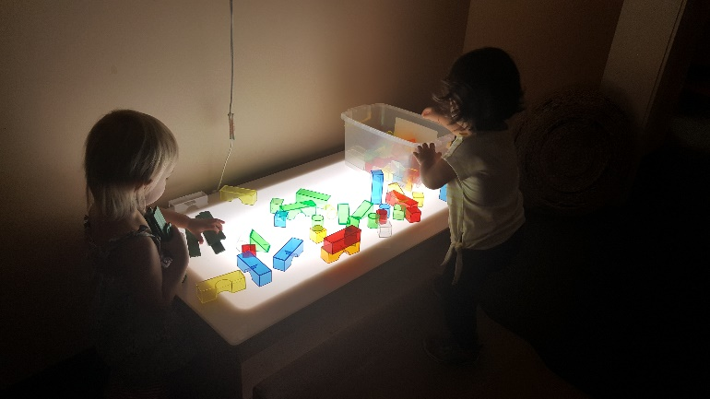**Light box**

**Shape and Pattern**: **(intent)** show an interest in shape and space by playing with shapes and making arrangements with objects/ (Mathematics)

**What you need (implement):** Transparent tangrams, Square transparent Counters, Round Transparent counters, Transparent fraction squares, coloured acetate, small weaker balls (all in the light box)

**What to do: (implement)**

* ASK the children to make patterns on the light box using the round transparent counters. Encourage younger children to make patterns by modelling the activity yourself alongside them.
* Add the square counters to the resources for making patterns, introduce a game for two children where one child make a pattern with the counters and the other one repeats the pattern.
* Add the other resources gradually (depending on child’s age) to make the patterns more complex and challenging.

**Vocabulary to introduce:**

Shape colour pattern counter

Round square circle triangle

Same different join

Big little near far

**DRAW SHADOWS**

Use building blocks to make shapes you can draw around. How does the Can you make some 3D shapes shadows to draw?

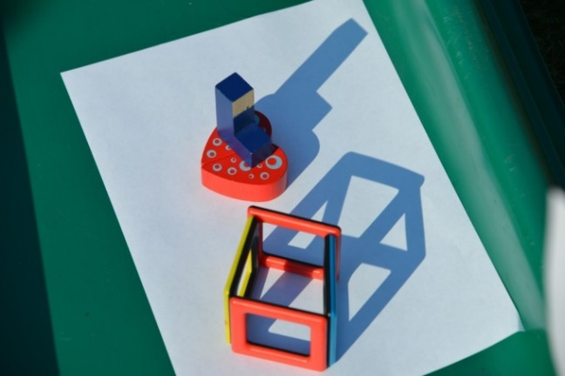 shadow change if you rotate the block? Is the shadow different at different times of day?

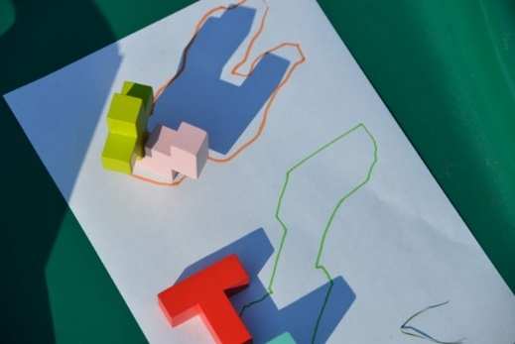

**Shadow sculptures; playdough animal shadow drawing**

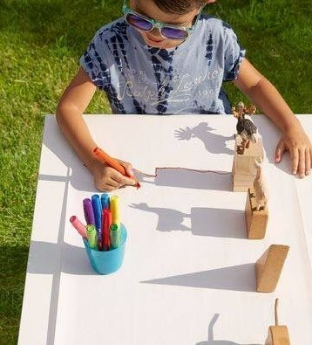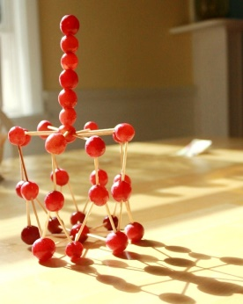

**TO MAKE OUR BUTTERFLY SILHOUETTE ART, YOU’LL NEED:**

* 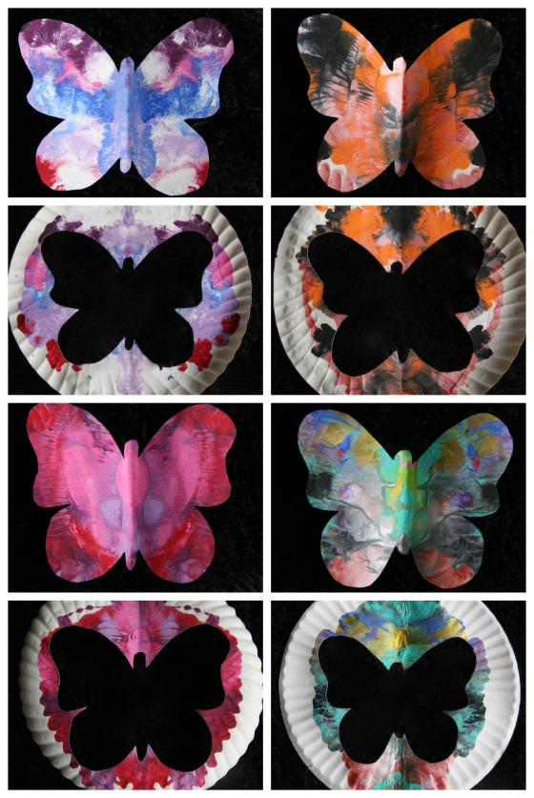paper plates
* 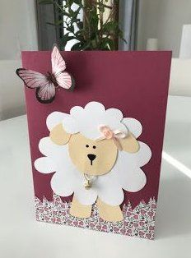craft paint
* paintbrushes
* scissors
* pencil
* a butterfly template to trace

Top of Form

|  |  |  |
| --- | --- | --- |
|  |  |  |
|  |  |  |

|  |  |  |
| --- | --- | --- |
|  |  |  |

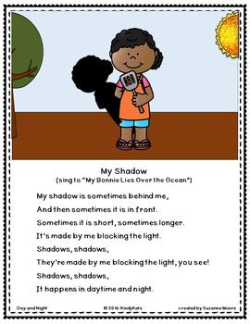

Bottom of Form

