Child interest:

Next step:

Mark making with crayons

Playdough (afternoons)

One to one story reading ;how do I eat it?

Eat your peas,Hungry duckling.

Five fat sausages rhyme

Brown leaf song

I can be ….game

Pone play

**C&L**

**PSED**

**Week**

**13 and20/09/2021**

**Fun with Food**

Musical instruments;

blocks playing

Heuristic play/treasure baskets

Farm Harvest sensory play.

Home corner play.

Cameras play

Dry Pasta play; explore the sense of sound (Monday 1)

Rainbow bread crumbs sensory play/

scooping and transferring

(Tuesday 1)

Farm Harvest Sensory Play (Wednesday 1)

Rice krispies crackle, crackle play (Monday 2)

Watermelon hand print craft (Tuesday 2)

Orange printing (Wednesday 2)

Brocolli and Belle peper printing (Thursday 1)

Rainbow spaguetti play (Thursday 2)

Easel painting (Friday 1 and 2)

Tunnel play.

Soft steps

**PD**

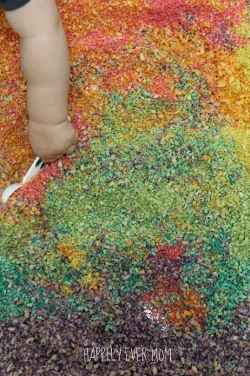Bread crumbs sensory play:

* **2 loaves of bread**
* [**Food coloring**](http://www.amazon.com/gp/product/B007EMYD8M/ref=as_li_qf_sp_asin_il_tl?ie=UTF8&camp=1789&creative=9325&creativeASIN=B007EMYD8M&linkCode=as2&tag=happilyevermo-20)
* **Milk**
* [**Food Processor**](http://www.amazon.com/gp/product/B001413A0Q/ref=as_li_qf_sp_asin_il_tl?ie=UTF8&camp=1789&creative=9325&creativeASIN=B001413A0Q&linkCode=as2&tag=happilyevermo-20)
* **Lightly toast**your bread
* Blend 1/6 of your **bread in the**[**food processor**](http://www.amazon.com/gp/product/B001413A0Q/ref=as_li_qf_sp_asin_il_tl?ie=UTF8&camp=1789&creative=9325&creativeASIN=B001413A0Q&linkCode=as2&tag=happilyevermo-20)
* Add**2-3 drops of food colouring** to roughly **two tablespoons of milk**(do this for each color)
* **Add the coloured milk to the bread crumbs** and blend
* **Lightly toast the breadcrumbs** or let air dry in an open bag

**Dry Pasta play; explore the sense of sound (Monday 1) :**

Implement**: dry pasta, empty water bottles, spoons; children fill the bottles with pasta, shake the bottles to explore sounds.**

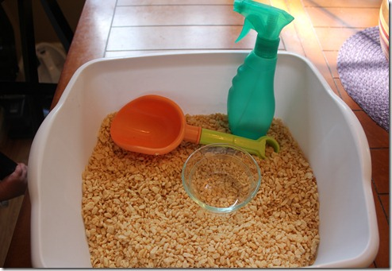**Rice kipsies crackle, crackle play:**

Add shovel, glass bowl, and a spray bottle filled with water. This is a great sensory activity because it encompasses so many different senses, touching the texture of the cereal and smelling it’s aroma. Hear it crackle when spaying it with water.

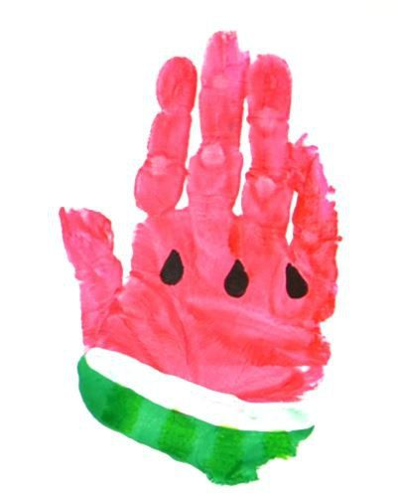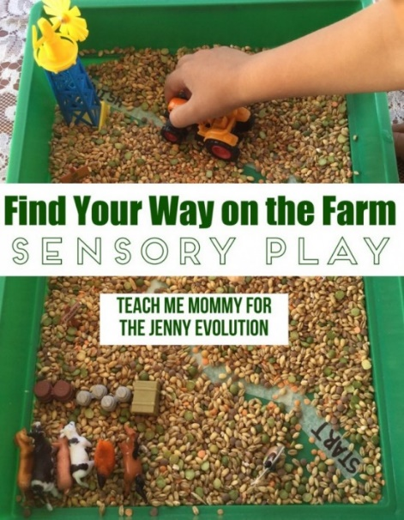**Brown leaf watermelon hand print**

Brown leaf, brown leaf, brown leaf

Falling off the tree,

Brown leaf, brown leaf, brown leaf

Falling, falling, falling, falling

On my nose,

Brown leaf, brown leaf, brown leaf

Falling off the tree,

Falling, falling, falling, falling

On my head,

Brown leaf, brown leaf, brown leaf

Falling off the tree,

Falling, falling, falling, falling

In my hand! (sang to snow flakes tune)

**Five Fat Sausages -**

*Five fat sausages frying in a pan*  
*All of a sudden - one went "BANG"!*  
  
*Four fat sausages frying in a pan*  
*All of a sudden - one went "BANG"!*  
  
*Three fat sausages frying in a pan*  
*All of a sudden - one went "BANG"!*  
  
*Two fat sausages frying in a pan*  
*All of a sudden - one went "BANG"!*  
  
*One fat sausage frying in a pan*  
*All of a sudden - it went "BANG"!*  
  
*No fat sausages frying in a pan.*

**Go Bananas, Peel Bananas (The Banana Song) - Lyrics**

*Peel bananas,*  
*Peel-peel bananas!*  
*Peel bananas,*  
*Peel-peel bananas!*  
  
*Chop bananas,*  
*Chop-chop bananas!*  
*Chop bananas,*  
*Chop-chop bananas!*  
  
*Smash bananas,*  
*Smash-smash bananas!*  
*Smash bananas,*  
*Smash-smash bananas!*

*Mix bananas,*  
*Mix-mix bananas!*  
*Mix bananas,*  
*Mix-mix bananas!*  
  
*Eat bananas,*  
*Eat-eat bananas!*  
*Eat bananas,*  
*Eat-eat bananas!*  
  
*GO BANANAS!*  
*GO-GO BANANAS!*  
*GO BANANAS!*  
*GO-GO BANANAS!*

I can be … game!

**Implement: (6-12mths)**

In a quiet place face the baby/infant

Bring animal puppets toward the child making the noise as you go.

The animal could tickle to increase enjoyment.

Say I can be a pig; oink oink or sing a song like Old McDonald had a farm.

**12-18mths**.

In quiet space, face the child,

Put toys in the bag and pull them out one by one making their sound as they come out.

Talk about the noise the toy might make.

Child may make some of the noises, let them experiment. Give them lots of praise.