Child interest: animal/water /book

Home croner play; Valentine tea party

story book (Being involved and concentrating)

Penguin song

Musical Instruments (Playing and exploring/ Listening nd attention)

Surprise bag (learning and undersanding new wrds)

Animal puzzle

Next step:

**PSED**

**Week**

**07 and 14 /02/2022**

**Fun with spices/Valentine**

**Pluto room**

Hide and seek Parachute game !

Ball pit (Monday to Friday)

Buble, buble blowing

Outdoor playing /taking risks ( playing and exploring;

be willing to have ago)

home corner play

pushchairs / baby walkers

Home made spice paint (Monday 1 )

Spicy sand gingerbread man (Tuesday 1)

Pouring and transferring paprika water (Monday 2)

Valentine craft (Wednesday 1)

Spicy Funnel painting (Tuesday 2)

Gram Masala mark making (Wednesday 2)

Spicy playdough Thursday 1/2

Painting on easel (Friday 1,2)

**PD**

 **Funnel Spicy painting Spicy sand gingerbread man play**

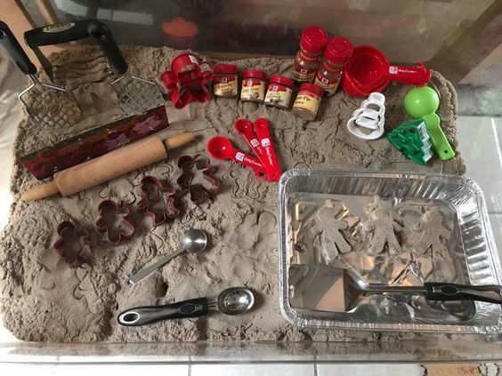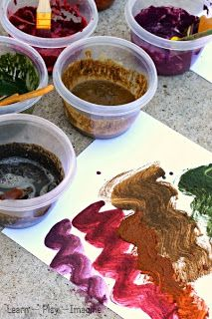

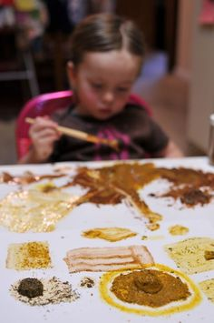**Gram Masala mark making**

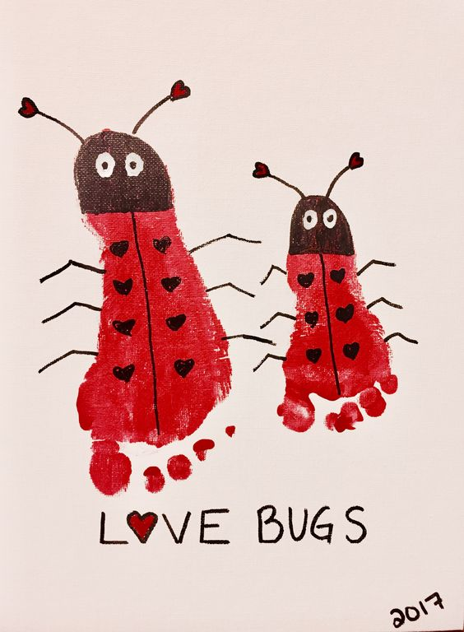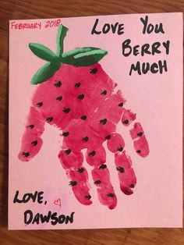

**Surprise bag:**

Intent: learning and understanding new words/ talk about the way items look, feel and sound.

Implement: put 3 or 4 objects that feel or look different in a bag, let the child pull something out tell him/her what it is, how it looks, feels and smells.

.

|  |  |
| --- | --- |
|  | **Penguin Song!** |