Child interest: animal/water /book

Stuck in mud

story book (Being involved and concentrating)

Penguin song

Musical Instruments (Playing and exploring/ Listening nd attention)

Surprise bag (learning and undersanding new wrds)

Animal puzzle

Next step: To produce animal sounds or use a sound

when shown or asked about

**C&L**

a animal. (Communication

and Language: speaking)

**PSED**

**Week**

**24 and 31 /01/2022**

**Mud is marvellous**

**Pluto room**

Colourful Mud painting (Monday 1 )

Chalk and Mud paint (Tuesday 1)

Pouring and transferring (Monday 2)

Mud theme block centre (Wednesday 1)

Mud, Mud ; Clean up! (Tuesday 2)

Pigs in the mud (Wednesday 2)

playdough Thursday 1/2

Painting on easel (Friday 1,2)

Brrrrrrr; it’s cold dress for it !

Ball pit (Monday to Friday)

Puddle jumping

Outdoor playing /taking risks ( playing and exploring;

be willing to have ago)

home corner play

pushchairs / baby walkers

**PD**

**Colourful Mud Theme Painting**

Materials Needed:  Mud, paint cups, water, food colouring, paint brushes, tagboard or poster board to paint on.

Put Mud into paint cups.  Add water.  Mix to a batter consistency. Add food colouring and mix. Paint and enjoy.

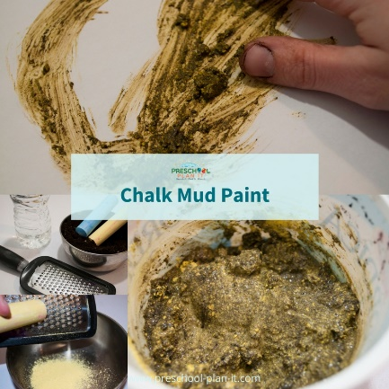**CHALK MUD PAINT**

Materials needed:  sidewalk chalk, cheese graters, Mud, water

Grate the chalk on a cheese grater. It will take a lot of chalk dust!

Mix Mud and water. Add grated chalk to each cup of mud.

Use with paint brushes or as finger paint.

Mud Theme Block Centre

Add dump trucks, cardboard pipes and small blocks or sorters that will fit in the piping.

The children work on ways to get the sorters or small blocks from one side of the block area to another.

**Mud, Mud Clean Up ! (water and mud play)**

Materials Needed:   mud, small basin of soapy water water, water toys, sponges, brushes.

Let the children clean up muddy toys

**Pouring and transferring Mud!**

Provide items for the children to scoop dirt into cups!

**Puddle Jumping!!!**

Create your own puddle in your yard by adding water to a dirt area.

If you do not have a dirt area, provide a wading pool with dirt and add water for the children to jump in! (appropriate clothing apply)

**Pigs in the Mud Movement!**

Talk about mud and how it feels. Now have children "invite" some piggies to jump in the dirt tray them.  Oh, the pigs are playful, they are running in the mud, let's catch them!

Oh, now the piggies are hot from all that running!  They like to cool down by rolling in the mud.  Let's help them!

Continue acting out other things that happen in the mud...perhaps they are walking and it begins raining and the dirt is turning to mud!  It is getting harder....and harder...to walk in, it is so mucky and sticky!!

**Surprise bag:**

Intent: learning and understanding new words/ talk about the way items look, feel and sound.

Implement: put 3 or 4 objects that feel or look different in a bag, let the child pull something out tell him/her what it is, how it looks, feels and smells.

.

|  |  |
| --- | --- |
| **Snowflake Song**  Snowflakes, snowflakes  Falling to the ground  Each one rests so gently  They never make a sound  Snowflakes, snowflakes  Are so pure and white  The special thing about them is  No two are alike! | **Penguin Song!**  To the tune of Twinkle, Twinkle, Little Star:  Penguins, penguins having fun,  Waddling in the winter sun.  Waddling fast and waddling slow,  Waddling to and waddling from.  Penguins, penguins having fun,  Waddling in the winter sun |