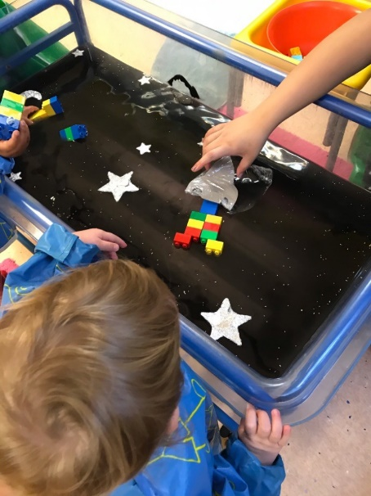**A peek to what have been learning**!

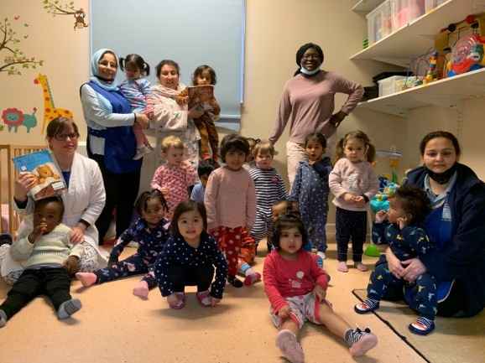Over the past few weeks we have been very busy enjoying great learning themes; Pyjamas, Day and night and Dinosaurs!

We have had a day dedicated to dress up and come to nursey in our Pyjamas and dressing gowns.  It was very unusual to see our teachers and friends in their funny colourful pyjamas! we could dress this way for nursery every day!

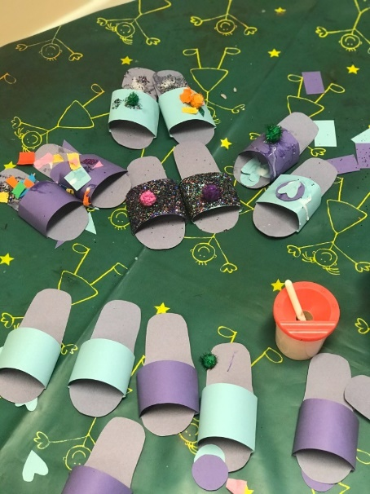We have also had a fun themed week with some many activities around pyjamas and going to bed!

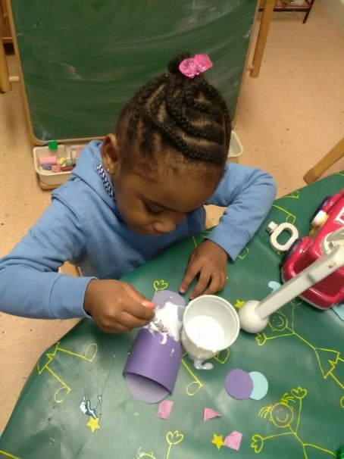We must highlight the painting with slippers; Yup, painting......with slippers!  Of course, not ours or our teachers but we hunt for old pairs and use them to paint with! It was great making different patterns from different textures on the bottoms of the slippers!

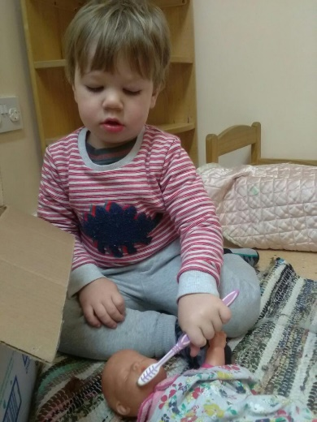We also enjoyed the Bedtime Box activity where the teachersfilled a box with bedtime items in it such as: pillow, toothbrush, toothpaste, brush, story book, etc. without seeing it,

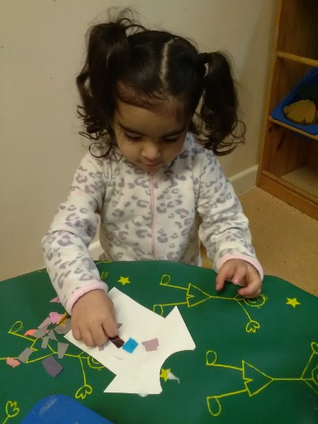The best part was to reach and in and feel an item and see if we could guess which bedtime item was!

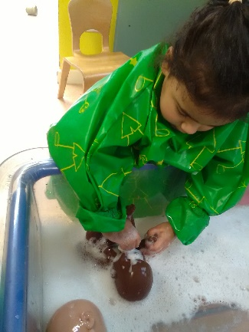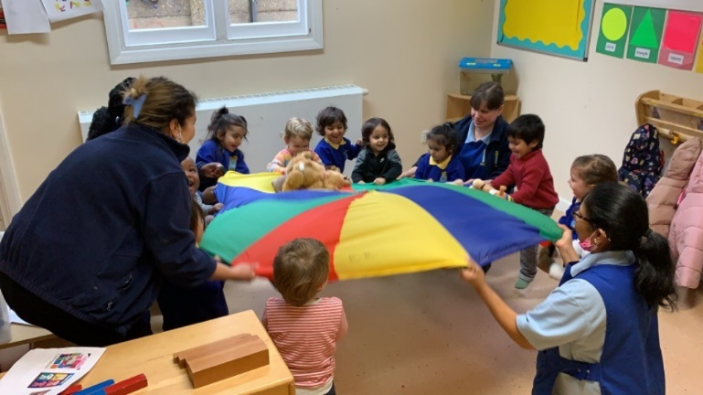As a group, we have had a such big fun at “Wake up the animals” parachute game. The animals were very, very tired.  We gently rock them to sleep by moving the parachute gently up and down without tossing the animals; shhhhhhhh, and when it was time to get up to get ready for nursery. We all used our loudest voice to  wake them up By shaking the parachute up and down!

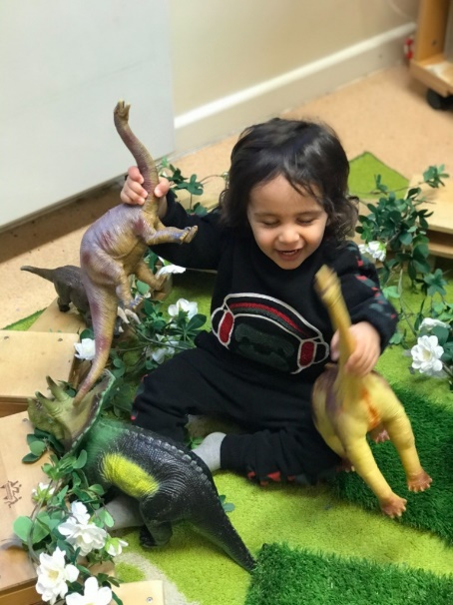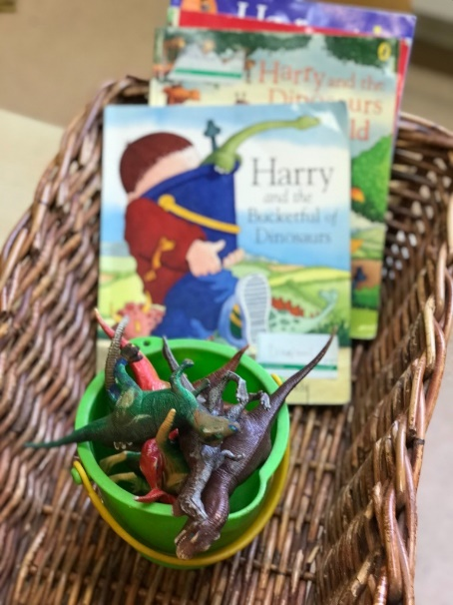Dinosaurs was the most popular theme amongst our toddlers and babies! Which is weird when we think about it because no one has ever interacted with one. However, we have shown a great fascination with these creatures. We have enjoyed copying the dinosaurs moves; we stomped around. We shook the ground and gave some fear by roaring “roarrrrrrrrr”!

We have also used the dinosaurs in our sensory play e.g. painting with dinosaurs, jump and wash with dinosaur’s sensory play, making prints on playdough and bubble wrap dinosaurs skin play!

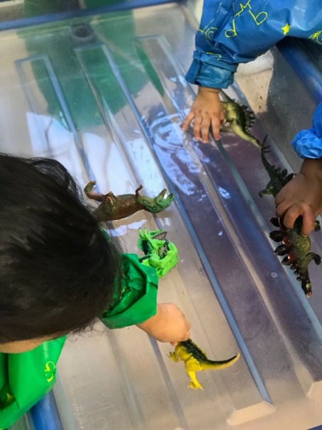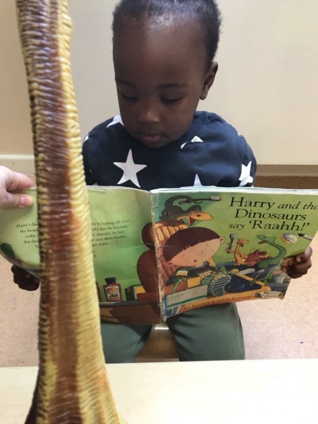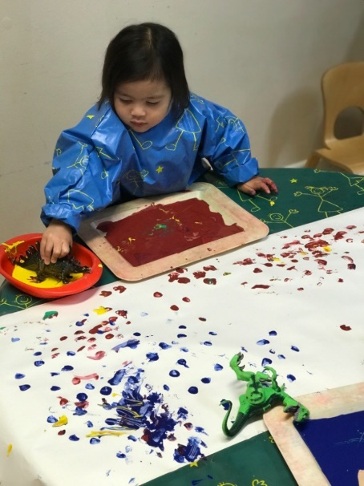

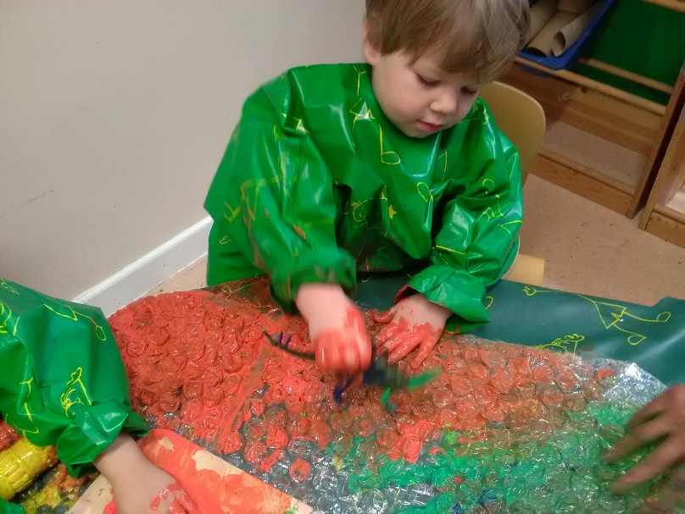

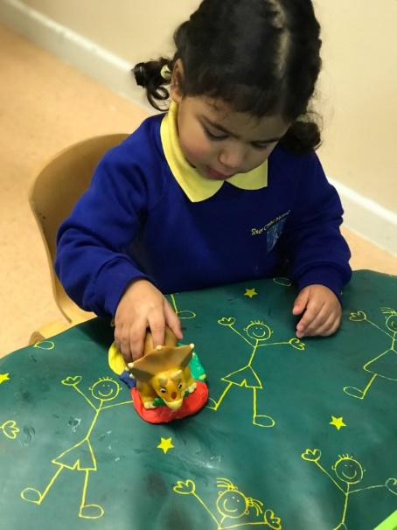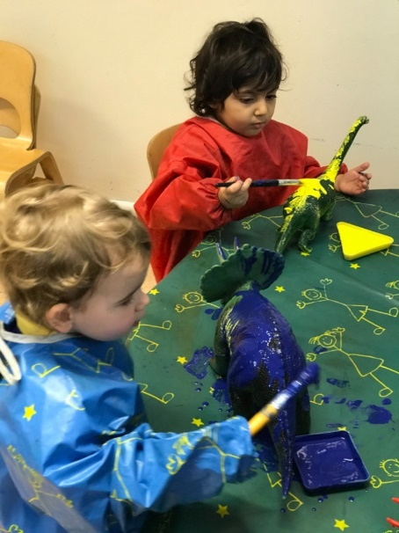

***Link to characteristics of effective learning*** - Playing and exploring – Showing curiosity about objects

***Link to the Early Years Foundation Stage*** – KW; Enjoy playing with small world models.

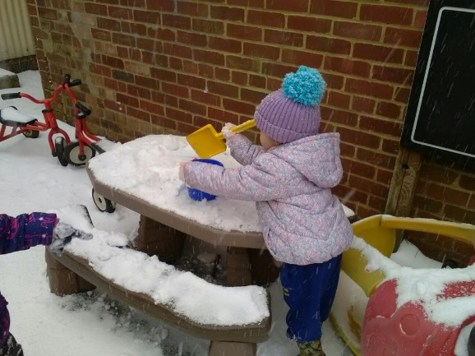As part of our “in the moment planning” we had great fun playing in the snow! We even brough the snow inside when it was too cold to go outside!

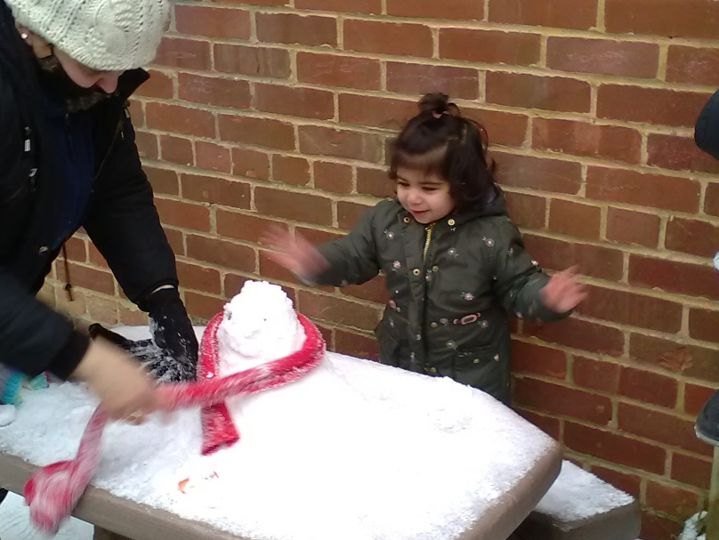

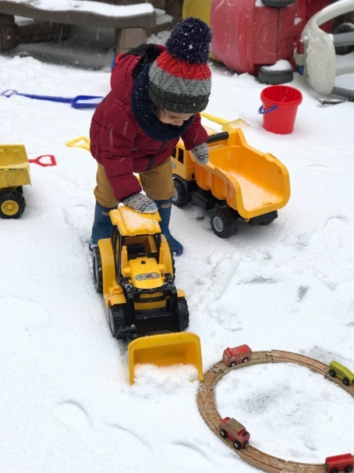

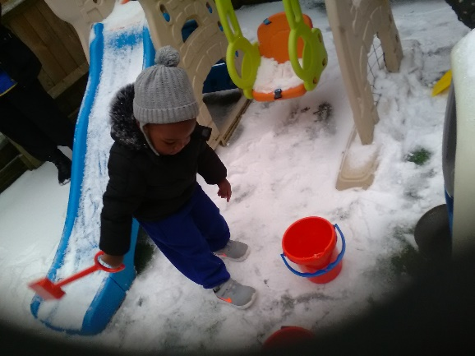

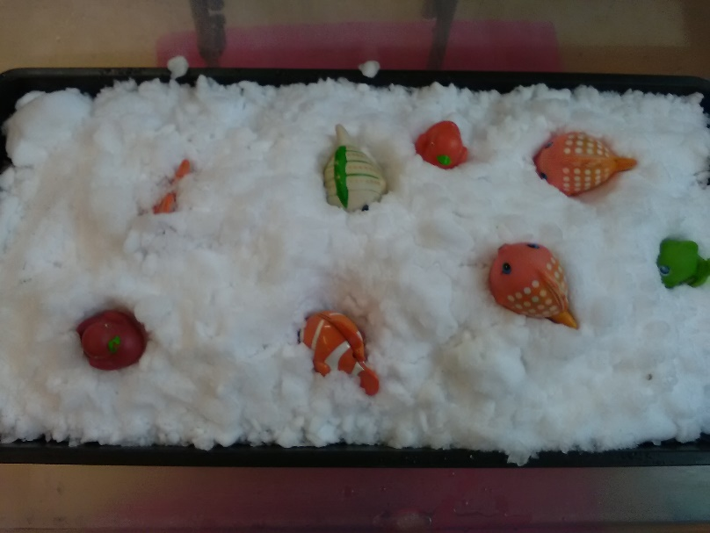

***Link to characteristics of effective learning*** -; Being willing to have a go

***Link to the Early Years Foundation Stage*** – PD; Show control in holding and using jugs, spades and buckets (22-36).

We have also enjoyed celebrating “Chinese New Year” by eating yummy sweet and sour chicken dish and egg roll pudding! We also made paper fans!

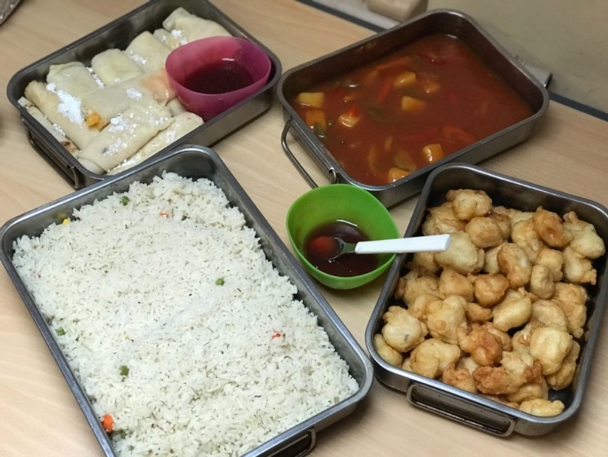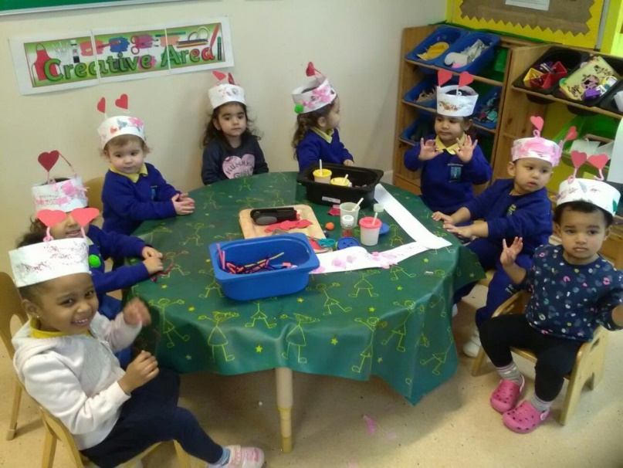For “Valentine’s day” we made lovely cards for our loved ones and gorgeous heart hats which we were very proud of!

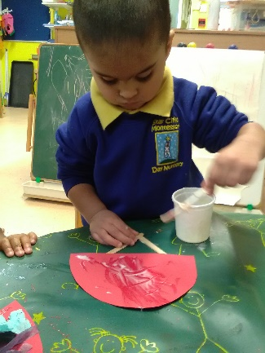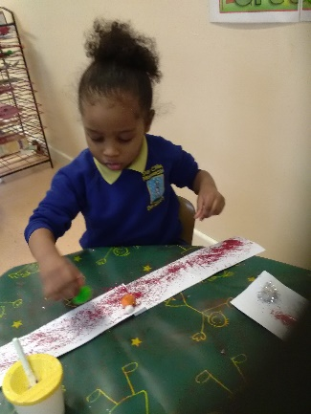

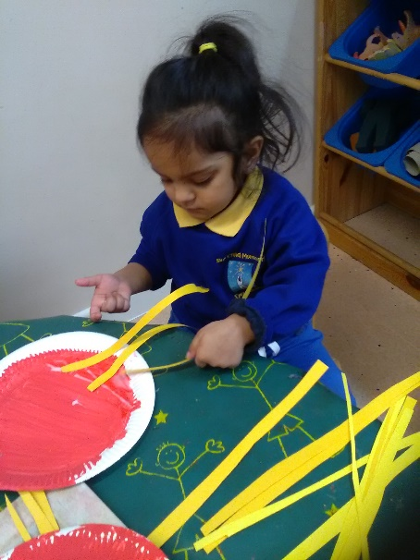

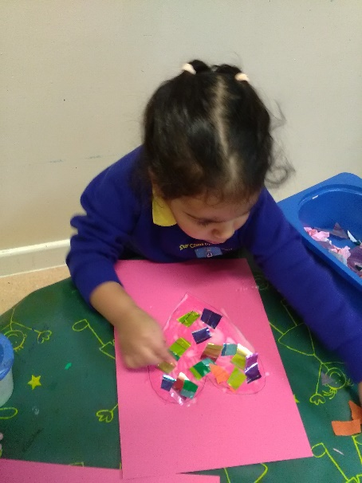

***Link to characteristics of effective learning*** - Playing and exploring – Representing their own experiences in play

***Link to the Early Years Foundation Stage*** – PSED; Express their own preferences and interests (22-36)