Jupiter/ Neptune

Stick Man by Julia Donaldson

How many different shades of brown can you find outside? Twigs, leaves, bark? Compare the shades with a colour tablets chart tablet Listening to woodland animal sounds (tablets)

The very helpful hedgehog story book

Block play (Playing cooperatively)

Playing outdoors/ scooters and swings (turn taking)

**PSED**

**C&L**

Child interest:

**Numeracy**

**Literacy**

Next step:

Hopscotch game

(Multicultural game)

Multicultural music

instruments

Hair Saloon role play

Lets ‘s jump (different jumping skills)

Tree climbing

Pouring and transferring

( water play)

Stick man colouring sheet

Tap your sticks

1,2,3 (Action song)

**Week**

**15 / 11/2021**

**22 /11/2021**

**Sticks/ Hedgehogs**

**Hanukah**

**KDW**

Sticks decoration (Monday 1)

Nature loose parts art (Tuesday 1)

Stick Ribbon wand (Wednesday 1)

Playdough and stiks sculptures Thursday 1.2)

Junk Modeling (Friday 1,2)

Leaves Hedghog craft (Monday 2)

Fork stamped hedgehog (Tuesday 2)

Chalk art Hedgehog (Wednesday 2)

S sound box

S is for snake tracing

sheet

H sound box

H is for Hedgehogs

tracing

Nature loose

parts counting;

leaves ,sticks ,acorns,pinecones

Making shapes uisng sticks

**EAD**

**PD**

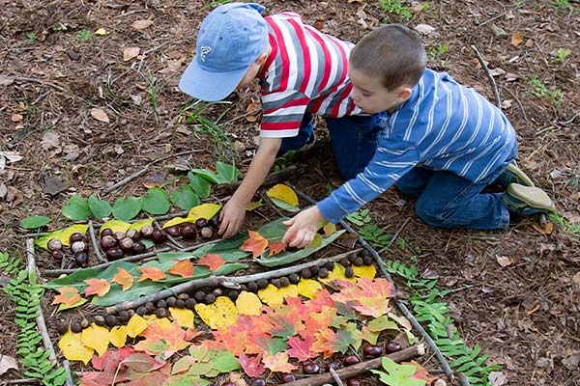**Maths Nature loose parts counting**

Create shapes using sticks. Try to make triangles that are different sizes and shapes. Challenge the children to make a hexagon or an octagon.

Bundle your sticks into piles of 10 and practice counting in groups of 10.

**Stick decoration:**

**Implement**: Paint your sticks white and wait for them to dry. Then add some coloured spots on these and display in a vase.

**Nature loose part art:**

**Implement:** Create a stick centre in your provision with wooden pegs, sticks, lolly pop sticks, leaves. acorns These make fantastic loose parts!

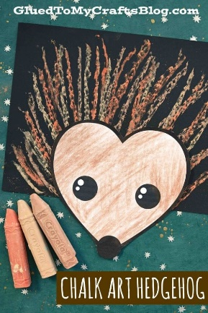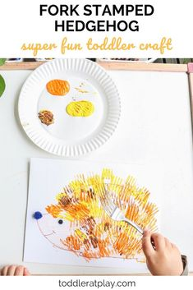**Leaves Hedgehog craft**

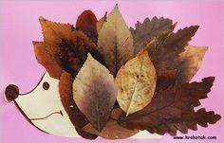

|  |  |
| --- | --- |
| **I am a little hedgehog**  Sung with I am little tea pot tune  . | Tap your stick 1,2,3 You tube  https://www.youtube.com/watch?v=M-UKTeWNgOk |