Child interest: animal/water /book

Next step:

(Communication

and Language: speaking)

Christmas song basket HJ/

The telephone game

One to one story reading

Name the things game (KS.HJ)

**PSED**

**Week**

**29/11 and 06 /12/2021**

**Christmas**

**Pluto**

I love you snow much Christmas card (Monday 1 )

Cotton ball snow man craft (Tuesday 1)

Ginger man playdough (Monday 2)

Salt dough hand print ornament (Wednesday 1)

Snow sensory play (individual trays) (Tuesday 2)

Christmas water sensory play with ornaments (Wednesday 2)

Mark making with crayons Thursday 1,2

Painting on easel (Friday 1,2)

Ball pit (Monday to Friday)

Train trucks play

Outdoor playing /taking risks ( playing and exploring;

be willing to have ago)

home corner play

pushchairs / baby walkers

**PD**

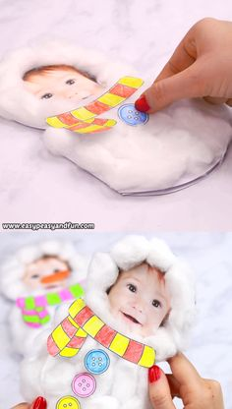**Salt dough ornaments**

* 4 cups All purpose flour
* 1 cup Salt

**Liquids**

* 1 1/2 cups Water

**Other**

* Clear Glaze Finish or Mod Podge

**Implement:** HOW TO BAKE SALT DOUGH ORNAMENTS

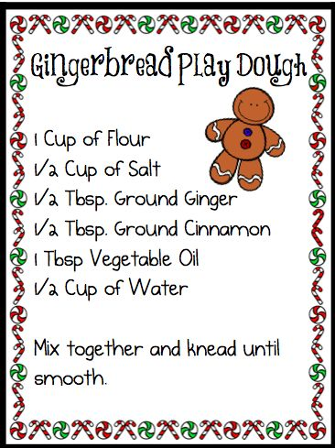1. Place the ornaments on a baking sheet and put in the oven at the lowest temperature possible. My oven was set to 170 degrees. 2. Bake the scented salt dough ornaments for 1 hour, then, flip them over and bake another hour. 3. Lastly, remove them from the oven and allow to cool. 4.decorate

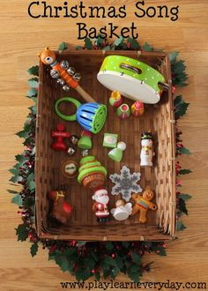**Snow sensory play:**

**Implement: to make the snow you will need to mix corn flour and vegetable oil**

**Decorate with pine cones and winter animals.**

**Christmas Water Sensory Play Activity with Plastic Ornaments**

Intent: Add plastic ornaments for active hands to dump, pour, and fill along with a baster for awesome fine motor skills. Simple sensory play for a Christmas win!

**Name the thing game**: Implement: Point to various objects in your room and ask the child to name them. You can help him/ her with the names until she/ he begins to say them on their own.

Intent: This is an easy way to build and improve their vocabulary. This game can be played anywhere – your room, in the park, or even in the playground.

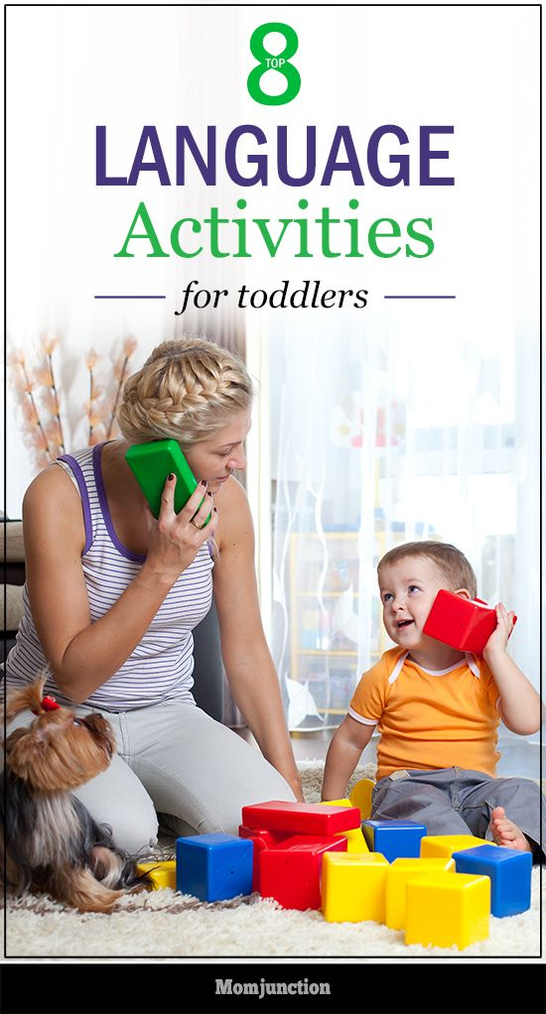

**The telephone game:**

**Implement: using any materials or a toy phone, engage the child to start a conversation about anything. with new words or songs.**

**Intent: To begin to use recognizable words.**