Child interest: animal/water /book

Home croner play; Valentine tea party

story book (Being involved and concentrating)

Penguin song

Musical Instruments (Playing and exploring/ Listening nd attention)

Surprise bag (learning and undersanding new wrds)

Animal puzzle

Next step:

**PSED**

**Week**

**21 and 28 /02/2022**

**Safari/Brown brown bear /pancake day**

**Pluto room**

Hide and seek Parachute game !

Ball pit (Monday to Friday)

Buble, buble blowing

Outdoor playing /taking risks ( playing and exploring;

be willing to have ago)

home corner play

pushchairs / baby walkers

Lion foot print (Monday 1 )

Brown bear, brown bear sensory tub (Tuesday 1)

Brown bear hand print (Monday 2)

Safari Jungle sensory tray (Wednesday 1)

Pancake day /Playdough (Tuesday 2)

Fork printing bear mask (Wednesday 2)

Paper plate Giraffe Thursday 1/

Safari Hat Thursday 2

Painting on easel (Friday 1,2)

**PD**

**Funnel Spicy painting Spicy sand**

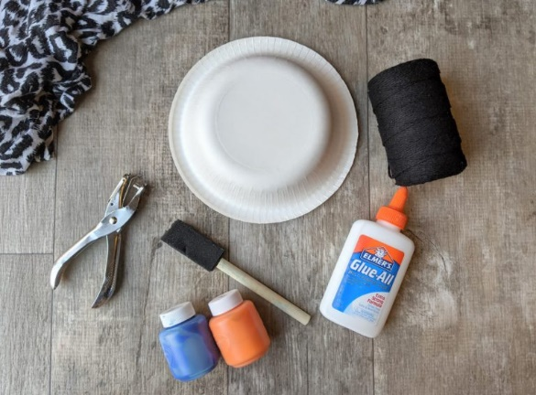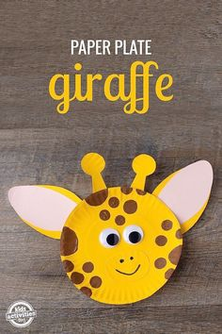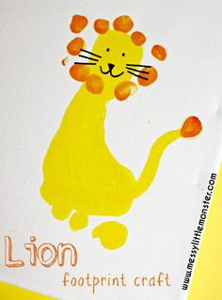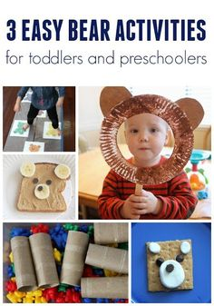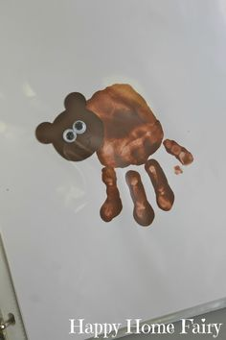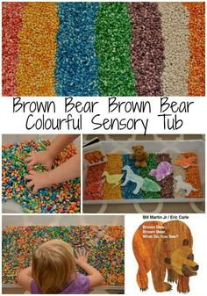

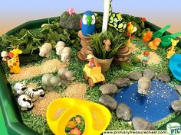

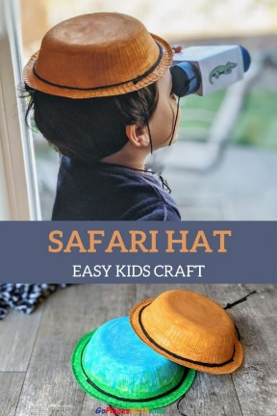

**Surprise bag:**

Intent: learning and understanding new words/ talk about the way items look, feel and sound.

Implement: put 3 or 4 objects that feel or look different in a bag, let the child pull something out tell him/her what it is, how it looks, feels and smells.



