Jupiter/ Neptune

If I were a spider /Miss Spider tea party story books

5 little pumpkins finger play

Pass the pumpkin

The old woman and the red pumpkin.

The forgetful spider story book

Block play (Playing cooperatively)

Playing outdoors/ scooters and swings (turn taking)

**PSED**

**C&L**

Child interest:

Next step:

Incy Wincy spider

(water play/pipes )

Invistigation tray

Lets ‘s jump (different jumping skills)

Tree climbing

Pouring and transferring

( water play)

Web breathing

**Week**

**18 / 10/2021**

**25 /10/2021**

**Spiders/Pumpkins/Halloween**

**KDW**

Ppaer Plate spider (Monday 1)

Sppider Loose parts art (Tuesday 1)

Playdough spider (Wednesday 1)

Easel painting (Thursday 1.2)

Junk Modeling (Friday 1,2)

Pumpkin leaf painting (Monday 2)

Black cat craft(Tuesday 2)

Hand Pumpkin (Wednesday 2)

Nature loose

parts counting;

leaves ,sticks ,acorns,

pinecones

Pumpkin hunt

Number work sheet

Construction

**EAD**

S sound box

S is for spider tracing

sheet

P sound box

P is for Pumpkin

tracing

spider web

representation

**Literacy**

**Numeracy**

**PD**

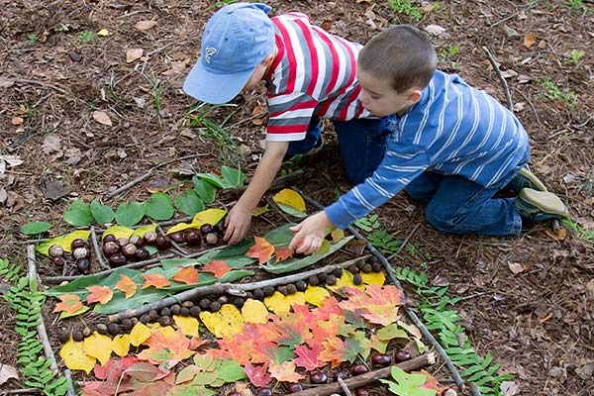**Maths Nature loose parts counting**

Create shapes using sticks. Try to make triangles that are different sizes and shapes. Challenge the children to make a hexagon or an octagon.

Bundle your sticks into piles of 10 and practice counting in groups of 10.

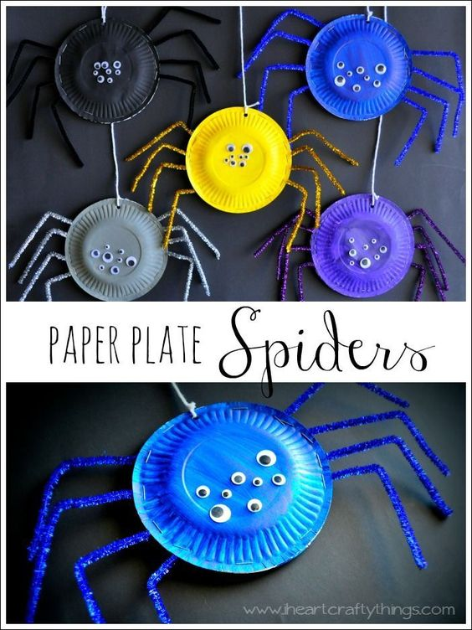Black cat craft

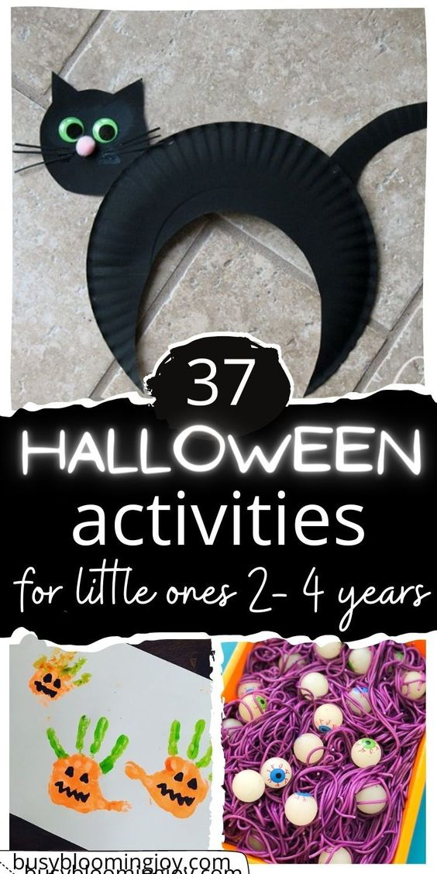

**Loose parts Spider art**

**Implement:** Provide a range of loose parts and photos of spiders to allow children the opportunity to create their own representations of them.

Playdough spiders:

**Implement:** In your malleable area make some black coloured playdough with your children and include books or photos of spiders, pipe cleaners, googly eyes, string, wooden numerals and numicon plates to allow children to explore the number 8.

**Incy Wincy** Spider (water play/ pipe)

Add some piping to your outside area or water play along with some toy spiders so children can sing and re-tell Incy Wincy Spider

**Web representation (Literacy):**

**Implement:** Provide black sugar paper and white crayons along with photos of webs to inspire children to create their own web representations.

**Investigation tray**: Collect some branches from outside, drape some pretend cobwebs and fairy lights and add some pretend spiders for an area of curiosity

**Pass the Pumpkin**

Bring a pumpkin to circle time. Pass it from child to child. Ask each child to say one word that describes the pumpkin and write them all down! (orange, heavy, dirty, smelly, etc.!)

**Pumpkin Leaf Painting**

Add pumpkin leaves or vines to use to paint with instead of brushes.

**Pumpkin Hunt**

Implement: Cut as many as you want paper orange pumpkins shapes, 1-15 or 1-20, depending on your age group.

Hide them all over the classroom and let the children go for pumpkin hunt. When they bring it to you they have to tell you what number is on the pumpkin.

**Hand Pumpkins**

Implement: Materials Needed: Brown construction paper, orange and green paint.The children make a fist shape with their hand. Dip their knuckles into the orange paint and then print knuckles onto paper (it makes a pumpkin). The children use their thumb to make a thumbprint on top of their pumpkin (it makes the leaf).

**Pumpkin facts**

Pumpkin is a fruit, not a vegetable. ·

Most pumpkins are orange. ·

They grow on all continents except on Antarctica. ·

Almost all parts of a pumpkin are edible.

Pumpkins were once used to cure snake bites and remove freckles.

**Spiders facts**:

There are so many types of spider in the UK.

Spiders all have 8 legs and many of them have 8 eyes too.

Spiders make webs by spinning the silk they make from the glands in their stomachs.

This is very sticky, stretchy and strong and for about a day and can be used to catch insects to eat.

|  |  |
| --- | --- |
| **5 Little Pumpkins Fingerplay**  5 Little pumpkins sitting on a gate (hold up 5 fingers).  The 1st one said "Oh my! It's getting late!" (Hold up 1 finger. Then pretend to look at their watches)  The 2nd one said "It's very windy out here!" (Hold up 2 fingers. Then move hands in air like the wind)  The 3rd one said "But we don't care!" (Hold up 3 fingers. Then hold hands up as you do when saying I don't know)  The 4th one said "Let's run and run and run." (Hold up 4 fingers. Then place fingers on floor and have them move as if they are running).  The 5th one said "Let's have some fun." (Hold up 5 fingers. Then wave hands and arms in air as though dancing!)  WOOOOOSH went the wind. (Make a loud woosh sound with the kids!)  OUT went the lights. (Clap hand very loudly when you say OUT loudly---if your children can handle it, have someone shut out the lights!)  5 little pumpkins rolled out of sight. (Make a rolling motion with your hands). | **Pumpkins are Growing**  sung to the tune of Frere Jacques  Pumpkins are growing.  Pumpkins are growing,  In the patch.  In the patch.  Look at all the pumpkins.  Look at all the pumpkins.  Orange and Round!  Orange and Round! |