Doll House, small world people

Memory game: who is missing?

Parts of the leaf fact sheet (circle time; Tip, blade, Vein)

Autumn leaves are

falling

Our Families (circle time)

Feeling Chart (Circle time

Leaves are falling Poem (Circle time)

Crunchy leaves sensory tray

**PSED**

**C&L**

Child interest:

**Numeracy**

**Literacy**

Next step:

Body match; musical game

Nature walk;explre leaves

Sweeping leaves in the

garden

Part of the leaves puzzle

Water Play; floating

leaves,

sinking conkers

Nature

Cracker face (snack time)

Healthy Me

Water play; soapy water,

sponges and pots

Cinamon Playdough/ face mats

Transferring conkers using tongs

**Neptune/Jupiter Week**

**13 / 09/2021**

**20/09/2021**

**Fall/leaves**

Scrunched tissue paper leaf (Monday 1)

I like… (Tuesday 1)

Real leaves and handprint craft

(Wednesday1_

Junk modelling

Paper towel leaves (Monday2)

Leaf prints (Tuesday 2)

Apple printing jar (Wednesday2)

Leaves Crown (Tursday)

Playdough (Friday)

**KDW**

Tracing pairs (Wedneday)

Leaves fossils in playdough

(Wednesday 2)

Leaf rubbing

M is for Me (tracing )

L is for leaf

Oval Me

Big and little; bear

family sorting

Big, small colouring bears

Counting conkers

4 Leaves colouring sheet

**PD**

**EAD**

**I Like...**

Materials Needed: A small picture of each child, magazines, scissors, glue, crayons, construction paper

**Implement:** The children glue their picture on the construction paper. They cut out items from magazines of things that they like such as: dogs, cats, flowers, family pictures, etc.

**Our Families: Circle time**

**Implement**: Tell the children to listen to what you are saying and stand up if what you say is true about them!

E.G: Stand up if you have a brother. Stand up if you have a pet.

Have the children standing name them (brother, pet, etc.)

Be sure to help children who aren't sure of the answers (Dee-Dee, you have a baby sister! Stand up! What is your baby sister's name?)

**Intent**: Help children PSED; being more confident to talk in group/

**Feelings Chart**

Bring a large piece of chart paper and a marker to circle time using the easel. This activity will get children thinking about different feelings (Intent).

Implement: Talk about what feeling mad, good, sad, scared, angry, silly, etc. means.

Then have the children call out endings to these sentences that you will put on the chart paper:

I feel angry when ___________

I feel sad when _____________

continue with others.

**Body Match Game**

Play music and have the children work in pairs. Call out a body part that they need to match. If you say "Knees" the children need to make one or both of their knees touch the knees of their partner!

**Memory game; Who is Missing?**

**Implement**: Introduce this game by starting in a group sitting down. Provide little people. Let the children give the family role name to each one: "This is the Mom. This is the Grandma. etc."

Tell the children to close and cover their eyes. Take one away and have them open and uncover their eyes and ask "Who is missing?"

**How to extend this activity:**

Once you have played this with them a few times, tell them you are now going to play "Who is missing" together!

Have an area near you where one child can stand and not be seen by the other children (behind a table, etc.).

Have all the children stand up, turn around (with their backs to you) and close and cover their eyes.

Choose one child to hide behind the spot you have chosen and have the others guess who is missing!

Intent: increase concentration/ language to describe who is missing.

**Tracing Pairs**

Children can be in pairs. One child will lay on a large brown paper and have his partner trace around body. They take turns tracing each other one their own paper. After body is traced then children can color, paint or collage body shape traced.

**Healthy Me**

Play music and encourage the children to join you in some healthy exercise! "Let's jog five times. Let's jump four times." Etc.

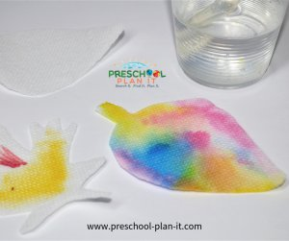**Paper Towel Leaves**: Materials: paper towels cut into leaf shapes; markers; eye droppers and water or a spray bottle with water.

Implement: Have the children color their leaf shapes with any or all colours. When done, have them spray (or use eye droppers with water) the shapes. Place them to dry--

**Nature Walk**

Take a walk around your local area and tell the children that they will be leaf peepers! Looking for signs of the leaves changing colour and documenting this. Talk to them; In Autumn you will notice that the leaves on the trees start to change colour but only on some trees.

There are two types of trees **deciduous** and **evergreens**. Deciduous tree leaves change colours, but evergreens do not.

A leaf is a flat, thin plant organ that uses the sun to make its own food.

The main flat area is called the blade.

The leaves change colour due to a lack of food.

Leaves contain **chlorophy**ll which make the leaves green.

They also contain **xanthophy**ll which make the leaves look yellow and **carotene** which make the leaves look orange.

During the spring and summer the leaves look green because they gets light from the sun and water from the ground, turns it into food and stores it . During the fall the days get shorter and the leaves cannot get enough light from the sun needed to make food. the leaf lives off the stored food and starts to loose their green colour.

When all the stored food is used up the leaf dies, turns brown and falls from the tree

**Leaves crown:** Materials: A selection of different coloured and types of leaves (smaller ones work best) PVA Glue Glue Spreader Greaseproof paper

**Implement** .1. Collect a variety of small leaves and dry them out, Cut off a long slice of grease proof paper and use the PVA glue to stick your leaves onto it. 3. Once your leaves are dry and stuck on staple your grease proof paper in a together (like a crown).

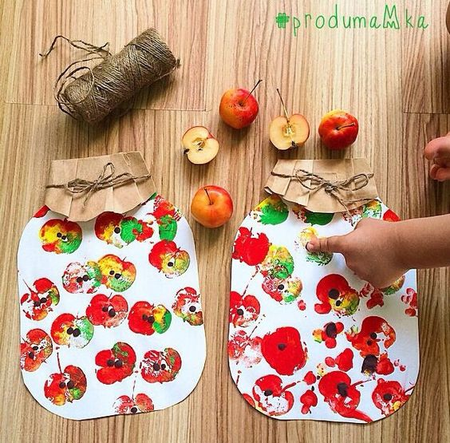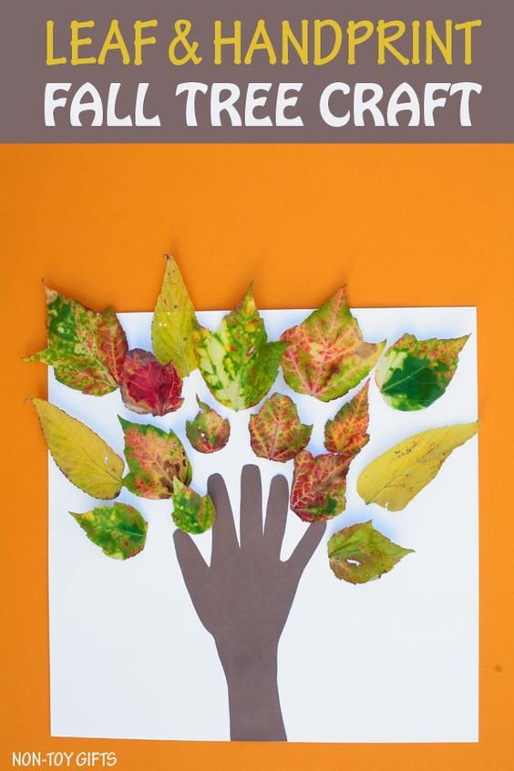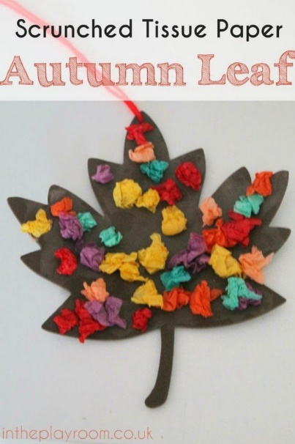

|  |  |
| --- | --- |
| **AUTUMN LEAVES TO THE TUNE OF LONDON BR IDGE**  Autumn leaves are falling down, Falling down,  falling down, Autumn leaves are falling down.  On the ground.  Find a broom and start to sweep, Start to  sweep, start to sweep, Find a broom and start to  sweep, start to sweep.  Make them in a great big heap, A great big  heap, a great big heap, make them in a great  big heap, on the ground.  But here comes the wind to blow them round,  Blow them round, blow them round, Here comes  the wind to blow them round, on the ground.  (repeat as many times as you like!) | Leaves Are Falling (poem)  Leaves are falling, leaves are falling,  One fell on my nose.  Leaves are falling, leaves are falling,  One fell on my toes.  Leaves are falling, leaves are falling,  One fell on my head.  Leaves are falling, leaves are falling,  Yellow, Orange, Red |