Child interest: animal/water /book

Peek-a-boo penguins story book (Being involved and concentrating)

Animal homes (blocks play) HJ/RG

Penguin song

Musical Instruments (Playing and exploring/ Listening nd attention)

Surprise bag (learning and undersanding new wrds)

Animal puzzle (JK)

Next step: To produce animal sounds or use a sound

when shown or asked about

**C&L**

a animal. (Communication

and Language: speaking)

**PSED**

**Week**

**15 and 22 /11/2021**

**Animals, Animals are everywhere**

Bubble wrap road (Monday to Friday )

**Black and White Penguin Collage** (Monday 1 )

Cotton ball winter rabbit craft (Tuesday 1)

Winter Animals print (paint) (Monday 2)

Polar bear hand print (Wednesday 1)

Playdough and animal cutters (Tuesday 2)

Sharks and whales in Foamy water (Wednesday 2)

Mark making with crayons Thursday 1

Painting on easel (Friday 1,2)

Ball pit (Monday to Friday)

Train trucks play

Outdoor playing /taking risks ( playing and exploring;

be willing to have ago)

home corner play

pushchairs / baby walkers

**PD**

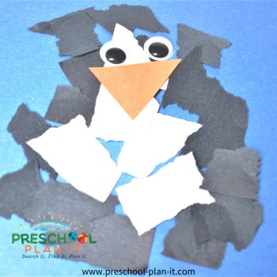**Black and White Penguin Collage**

Materials Needed: Pictures of penguins; black and white scraps of paper; wiggly eyes; small orange triangles (for beaks!); school glue; construction paper to glue collage on.

Implement: encourage the older children to tear the paper first then give them glue and them be as creative as they can be! (read story about penguins and show them pictures of penguins)

Intent: learning new words black bodies, white belly , eyes, beak, etc.).

Intent: Tearing the paper is great for their fine motor skills.

**Story books**

**Peek-a-boo penguins (Sea animals)**

**Animal Homes**

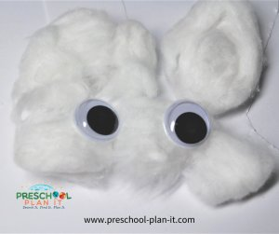**Implement**: Use large stuffed animals in your block area. The children can then make homes for them with the blocks or the toy animals can make homes for themselves!

**Winter Rabbits**

Implement: Provide glue, 2 wiggle eyes and a bin of cotton balls for them to make their rabbit!

Intent: So much fine motor development going on with gluing on the cotton balls! This activity also helps them to develop their eye-hand coordination.

**Polar bear hand print sharks and whales in foamy water**

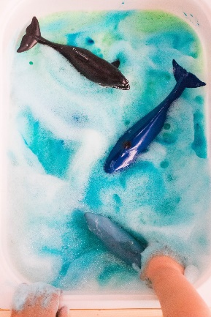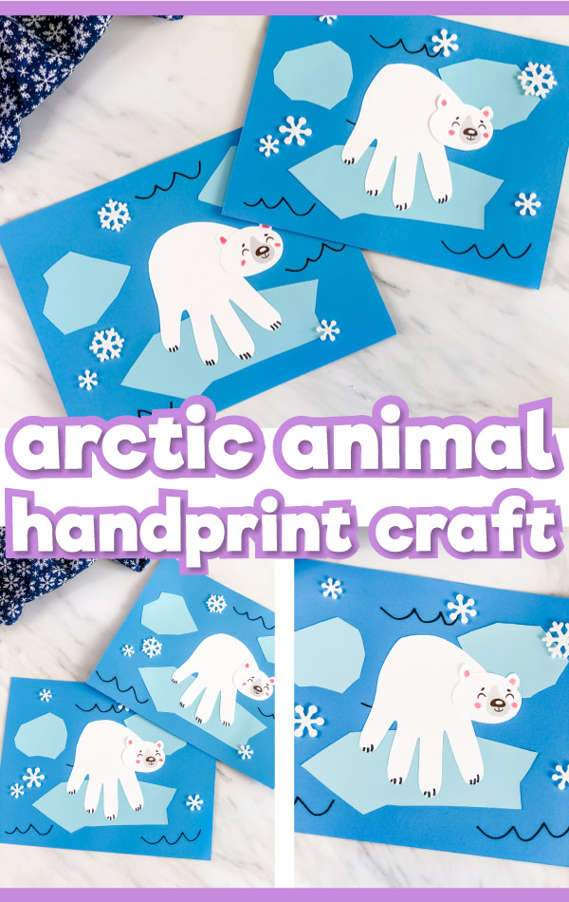

**Penguin Song!**

To the tune of Twinkle, Twinkle, Little Star:

Penguins, penguins having fun,

Waddling in the winter sun.

Waddling fast and waddling slow,

Waddling to and waddling from.

Penguins, penguins having fun,

Waddling in the winter sun.

Surprise bag:

Intent: learning and understanding new words/ talk about the way items look, feel and sound.

Implement: put 3 or 4 objects that feel or look different in a bag, let the child pull something out tell him/her what it is, how it looks, feels and smells.