Child interest: soft toys teddy bears

Next step:

A box of everyday things game

(Monday-Wednesday)

Honey Playdough (Wednesday)

One to one story reading ;Teddy bear picnic,

Can you see a little bear?

Teddy bear,teddy bear song.

Bubbles; pop, more, again, bubble

again, bubbles please

Brown leaf song

**C&L**

**PSED**

Musical instruments;

Teddy bear needs a home;

blocks playing

Teddy bear picnic; Mama bear,

Papa bear and baby bear

Autumn investigation box

**Week**

**30/08 and06/09/2021**

**Teddy bear/Pluto**

Teddy needs help dressing (Monday-Friday)

Fuzzy bear prints (Monday)

Painting on Easel (Wednesday )

Porridge play ; scooping dry and

Wet porridge messy play (Tuesday)

Fall leaves soup ;water play (Thursday )

Autumn colours free hand prints (Monday 1)

Leaf sticking (Tuesday 1)

Mark making wit crayons (Friday)

**PD**

Teddy Bears are so cute, and cuddly, and a great theme for babies who shown an interest in soft toys in general and Teddy bears in particular.

**A box of everyday things game: learning and understanding new words (CL) (Intent):**

**Implement:**

1. Put a few everyday objects into a box e.g a cup, spoon, book, shoe vest, nappy, ball anything that they are likely to see every day.
2. Choose something and give to the child name it, let him or her explore it with their hands.
3. Make comments such as: cup for drinking, spoon for eating.
4. Sing a song like” This the way we brush our hair, brush our hair early in the morning”.

**Teddy needs help with dressing: (Intent: Learning new words/ PD Show a desire to help with dressing and undressing and hygiene routine)**

**Implement:**

1. Put some everyday objects in a box: socks, flannel, toothbrush, brush.
2. Involve a teddy.
3. As you take items out of the box use them on the teddy.
4. Show how you brush your teeth, wash face, put socks on, let them have a go-it does not matter if it’s not right.
5. Tell them what’s happening” you’re brushing teddy’s hair.
6. 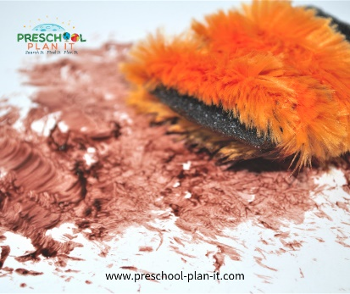Repeat with remaining items.

**Fuzzy Bears Prints** : Materials Needed: faux fur paint brushes, paper, googly eyes.

Implement: Use pieces of faux fur dipped in brown paint and to press onto their paper and leaves prints. Add googly eyes to give it a finish looking teddy bear touch.

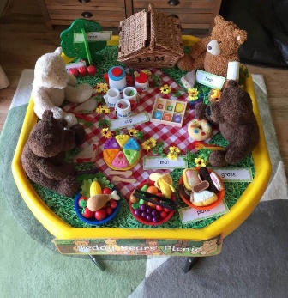**Teddy Bear, Teddy Bear Teddy bear picnic**

This is a traditional song to sing while using bears props!

Teddy Bear, Teddy Bear, turn around.

Teddy Bear, Teddy Bear, touch the ground

Continue with verses and make some up, too!

...wiggle your shoes...that will do.

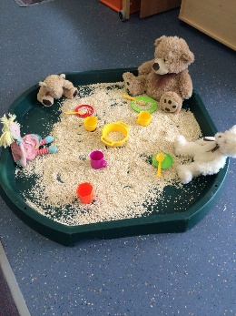...climb the stairs, say your prayers Porridge play

...turn off the light...say good-night!

**Ingredients for Honey Playdough:**

* 2 c. flour
* 3/4 c. salt
* 1 tbsp olive oil
* 1 c. water
* 1/4 c. honey / food colouring (optional)

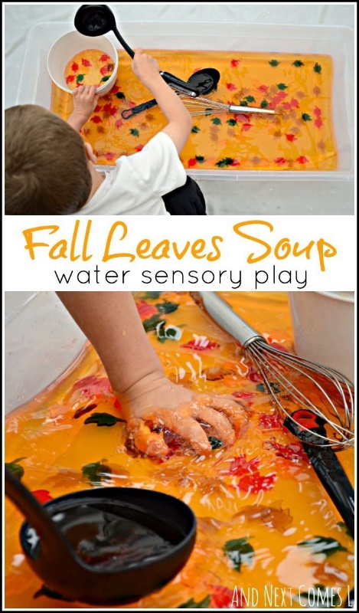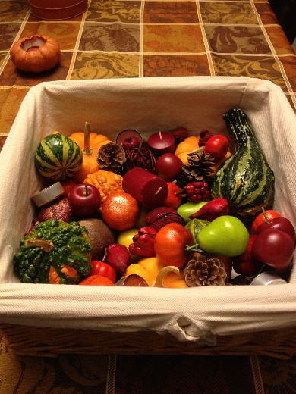**Brown leaf** Autumn Investigation box

Brown leaf, brown leaf, brown leaf

Falling off the tree,

Brown leaf, brown leaf, brown leaf

Falling, falling, falling, falling

On my nose,

Brown leaf, brown leaf, brown leaf

Falling off the tree,

Falling, falling, falling, falling

On my head,

Brown leaf, brown leaf, brown leaf

Falling off the tree,

Falling, falling, falling, falling

In my hand! (sang to snow flakes tune)