Next step: - Place objects in, on and under on request.( CL, Understanding) ZC/YL

- Point to picture of common objects described by it use ( CL, Understanding)

(circle time/ Monday to Friday)

Bed time bag game

Whats missing !(Being involved and concentrating)

( ZC/JL)

Good night show and tell

One to one reading (Listening and attention )

Bananas in Pyjamas Playtime book

Good Night Sleep

Goodnight... Kind of Feeling

Ten in a bed

Good night show and tell! (Being willing to have a go)

Bedtime stories

Musical instruments (Playing and exploring)

Wake up pets group game

Baby bath time (water play)

**C&L**

**Week 03/01 & 06/01/21**

**Pajamas**

**Venus Room**

**PSED**

Good nigh moon collage (Monday1)

Slippers painting (Tuesday 1)

Bedtime scene (Wednesday 1)

playdough Quilt (Thursday 1)

Slippers Art and craft (Monday 2)

**(**Tuesday 2) paper plate quilt

Design your own Pajamas (painting) (Wednesday 2)

Bed time playdough; moon and star cutters (Thursday 2)

Junk modelling (Friday 1,2)

**PD**

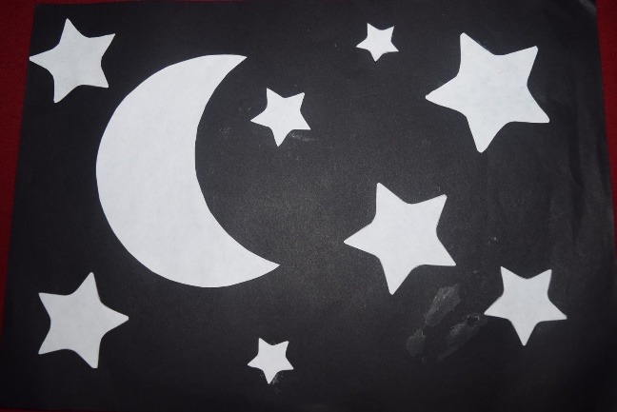Good night moon collage

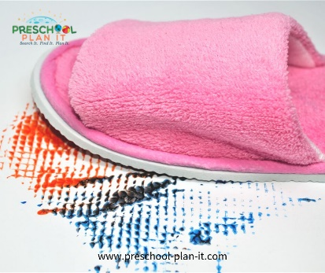

**Slipper Painting**

Yup, painting......with slippers!  Not the children's or yours!  Find an old pair (or ask parents to donate old pairs) and use them to paint with! It is best to find pairs with different textures on the bottoms!

**Bedtime Bag**

Bring a pillowcase and a bin or box with bedtime items in it such as: pillow, toothbrush, toothpaste, brush, story book, night light, etc.

Be sure the children can not see the items in the bin or box. Place one item in the pillowcase (without the children seeing it).

Have each child reach in and feel an item and see if they can guess which bedtime item is in the bag.

Extension: **What's Missing?**

Using the items above, place them all out in front of the children.

Have the children close their eyes.  Take one item away and hide behind your back or under the pillowcase.

Have the children guess which item is missing.

**Bedtime Stories**

Bring flashlights, pillows and blankets to circle for your story time.

The kids love this!  Read the story using the flashlight to shine on the pages!

**Good Night Show and Tell (Wednesday 13th January pyjama day dress up for children and teachers in Venus Room).**

Implement: Assign one day as a Good Night Show and Tell day.  Each child brings in something that reminds them of bedtime, night time, or the book Good Night Moon. The each take a turn showing their friends what they brought in and telling why it reminds them of night time.

**EXTENSION**:  Take pictures of each child with their item.

Print the pictures and put together your own Good Night Venus Room book...the children will LOVE reading this in the library and having it read to them by you at circle time!

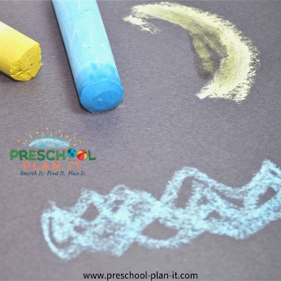**Bedtime or Nighttime Scene**

Provide black paper and chalk for great night time scenes.

VARIATION:  Provide warm water with diluted salt for the children to dip the chalk into.   The result is quite sparkly when the chalk dries!

**Wake up, Pets!**

Materials needed:  Parachute or large blanket and stuffed animals

Implement: Place one (or more) animals on the parachute.

Tell a story about the animals.

"The animals are very, very tired.  Let's gently rock them to sleep"  Show the children how to move the parachute or blanket gently up and down without tossing the animals.

"The animals have been sleeping for a long time, I think they are dreaming!"  Show the children how to move the parachute up and down to gently move the animals up and down.

"Well, it is time to get up to get ready for school.  WAKE UP ANIMALS!" Now shake up and down to wake the animals up.

In advance, you may want to assign TWO children to get the animals when they fly out of the parachute.

Then assign 2 different children each time you play.

This prevents all the children from running after the animals and bumping into each other.

**Intent:** waiting for turns/ sharing/ listening and attention.

**Playdough Quilt**

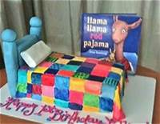Implement: Provide a wide variety of colours of playdough. Have the children manipulate, tear and press small pieces of playdough to make a colourful quilt!

Show them pages from the Llama, Llama Red Pajama book for a quilt idea!

**Intent:** This is GREAT exercise for those hand muscles! as they are necessary to successful printing/writing!

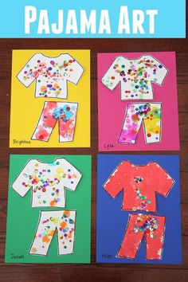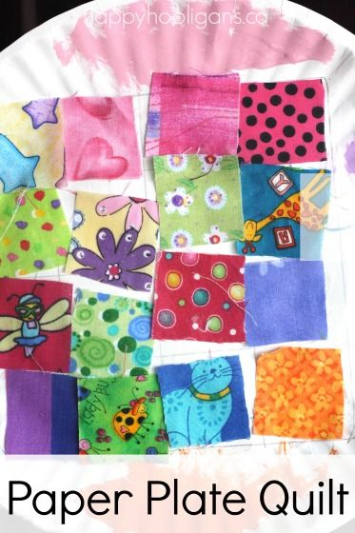

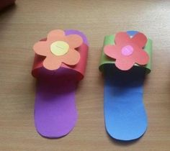

|  |  |  |
| --- | --- | --- |
| **10 In The Bed**  There were 10 in the bed and the little one said, "Roll Over!  Roll Over!".  So they all rolled over and one fell out.  There were 9 in the bed and the little one said, "Roll Over!  Roll Over!".  So they all rolled over and one fell out.  Continue with 8,7,6,5,4,3,2 and then  There was 1 in the bed and the little one said, "GOOD NIGHT!". | **Teddy Bear, Teddy Bear**  Teddy Bear, Teddy Bear, turn around.  Teddy Bear, Teddy Bear, touch the ground.  Teddy Bear, Teddy Bear, tie your shoes.  Teddy Bear, Teddy Bear, that will do!  Teddy Bear, Teddy Bear, go upstairs.  Teddy Bear, Teddy Bear, say your prayers.  Teddy Bear, Teddy Bear, turn out the light.  Teddy Bear, Teddy Bear, say goodnight! |  |



