Next step: - Place objects in, on and under on request.( CL, Understanding) ZC/YL

Dimond hunt sensory bin play (playing cooperatively)

Rock collection (walking to the local park)

(Being willing to have a go)

Musical instruments/ Noisy play Soldiers (Playing and exploring)

Stone tower (pretend play)

(circle time/ Monday to Friday)

One to one reading (Listening and attention )

Rock band (explore sense of hearing)

Hide and seek a sound (Listening and attention) AG/Ks/JJ

Posting boxes (building sentences) Ks/ IK

**C&L**

**PSED**

**Week 16/08 & 23/08**

**Pebbles and rocks**

**Venus**

**Painting with Rocks/pebbles (** (Monday1)

Pebbles water painting (Tuesday 1)

Rock rumble; shake painting with rocks Pet rock (Wednesday 1)

Playdough / Easel painting (Thursday 1)

Crayon melt craft (Monday 2)

**Rock museum (**Tuesday 2)

Playdough (Wednesday 2)

Easel water painting / stone sticking (Thursday 2)

Junk modelling (Friday 1,2)

**PD**

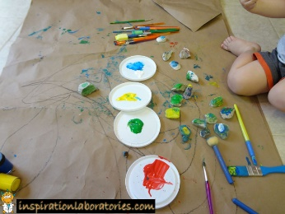 **Painting with Rocks**

**Implement**: Place paper in a shallow box cover or tray. Plop on a few colours of watered-down paint.

Add a few rocks. Shake the box left to right and in circles. COOL designs!

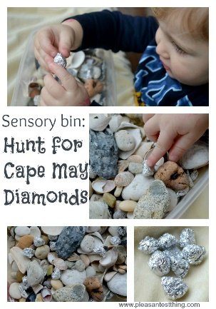DIAMOND HUNT sensory play

**Implement**: seashells and stones collected put into a sensory bin. Crumple some aluminum foil into small balls and add those to the bin. The foil balls are the “diamonds” that children would search for in the bin. Diamonds will sparkle!

Key vocabulary: Rough, smooth, flat, round, big, little, hard, warm, cold, colours, lines, marks, spots, shapes.

**Rock band:**

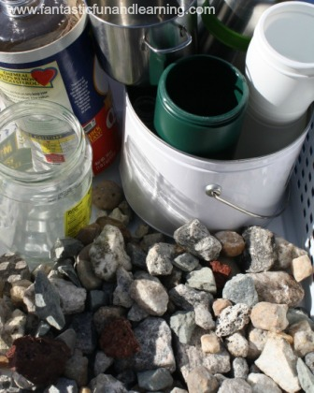**Intent**: explore the sense of hearing.

**Implement**: gather rocks and a few different containers from recycling bin and around the nursery. Try to find containers that are made of different materials, and I also made sure most of them had lids that attached securely. Start by practicing being *very quiet*. Then the kids each chose a container and a rock, and we listened as each person drop their rock into their container. Talk about the different sounds you hear. Next let the children spend some time freely exploring with the different containers and rocks. Encourage them hearing them compare the different noises e.g dropping small pebbles into water bottle; it sounds like rain.

After a while introduce filling up the containers completely. Next encourage the children to make an instrument by adding a small handful of rocks to their containers and put the lids on and making some good beats!

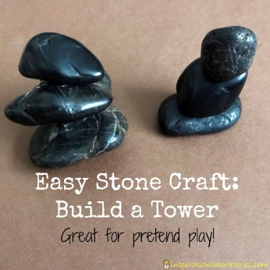

Stone Towers

Encourage the children to use flat rocks to stack them and make towers.

Key vocabulary: Rough, smooth, flat, round, big, little, hard, warm, cold, colours, lines, marks, spots, shapes.

**Rock rumble; shake painting with rocks**

**Implement**: you will need large containers with lids, paper, and paints and you’ll need rocks!  Lots of little rocks.  Slide the paper into the container (you may need to trim to fit), and drop in a handful of rocks.  Drop in a few colours of paint onto the rocks, seal the lid, and then, with one hand on the lid and one hand on the bottom, have the children shake, rattle, and roll.

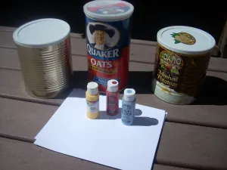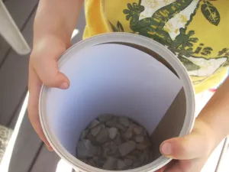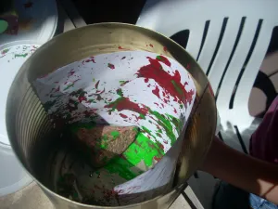

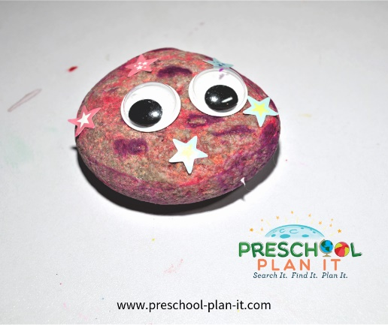**Pet rock:**

**Pet Rock**: Have the children collect a rock for a pet.  Have them paint, colour it with markers, stickers and give them googly eyes.  Have them name it!

**Crayon Melt Rocks**

Collect large rocks place them in the sun to warm up then use crayons to color with.  The crayons will melt as they use them from the rock being warm.

**Rock Museum**

Provide tables, trays, cash register, bags and other items.

|  |  |
| --- | --- |
| What’s in the bag songs and props . | Books  Princess Poppy –  The Fair Day Ball  Little red riding hood |

.