‘ Next steps:

Once upon a time we took a trip to the moon, cooperative story telling (circle time)

Stars in the sky song

Outer space poem

Pootle 5 in Space!

Roaring rockets story

Roaring Rockets

Cooperative story telling (being confident to take part in group )

Which colour is missing (Being patient / taking turn)

**PSED**

**C&L**

Child interest: books/water play/Group games

Next step:

Stars in the sky song

Our own spaceship role play

Bathing in space water play

Which colour is missing

(St Patrick day)

**Week**

**14/03/2022**

**21/03/2022**

**Space/Astronaut**

**Jupiter/ Neptune**

**Planet Bean Bag Toss**

**Get fit obstacle course**

Making orange Juice

Water play: pouring and transferring

Making snips on paper

Healthy and non-healthy food bingo

kk

Painted planets (Monday 1)

St patrcik day craft (Tuesday 1)

Nigth sky mural (Wednesday 1)

Papa please get the

moon for me craft (Thursday 1)

(Friday 1,2) Free colouring and drawing

Alien spcaeships (Monday 2)

Foil printed moon/moon craft (Tuesday 2)

Sun craft (Wednesday 2)

Playdough (Thursday 2)

Go green(Easel painting)

Thursday 17th March

**KDW**

Moon Rock Sorting

Moon rock counting

Trace and count

Broad stairs

Pink tower

3D solid shapes box

A letter box

Space poem

Pink box series “o””a”

”e”and “I”

A is for astronaut

**Literacy**

**EAD**

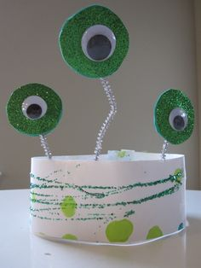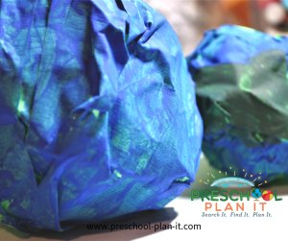**Painted Planets**

Materials Needed: newspaper, masking tape, paint

**Implement**: The children can create their own planets by crumpling a piece of newspaper into a ball and then taping it.  
If you have a model of the planets hanging nearby, they can try to create a planet similar to Earth, Mars, etc., but why not create their own and then name it!

When dry, hang from the ceiling!

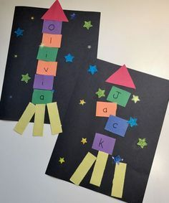**Space Rockets** Alien spcae ship

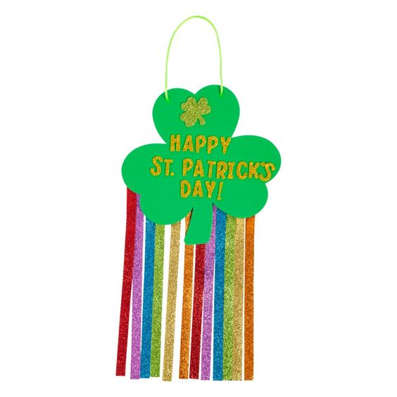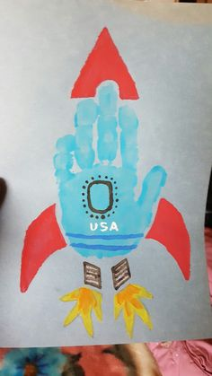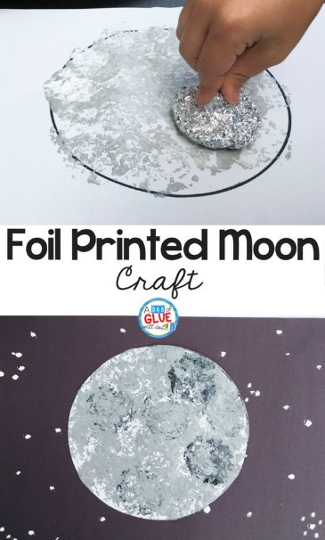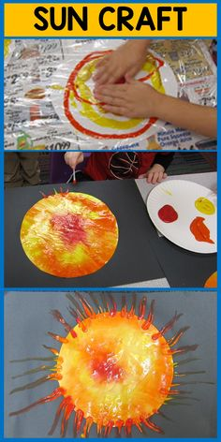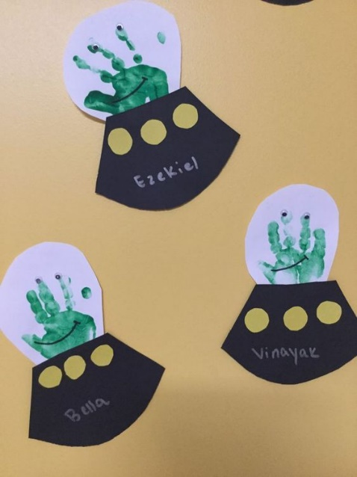

**Night Sky Mural**

Materials Needed: Large mural paper; paint in blue, black, gray, Star stickers, bath scrunchies or round sponges; variety of paint

Directions:

Implement: Decorate the universe! Use Star stickers. Use sponges to sponge paint planets, moons, stars, the sun!

**Once upon a time, we took a trip to the moon!** **Cooperative Story telling**

Materials Needed: Paper, pen!

Intent: cooperative stories are great, and silly and fun! Tell the children that they are going to make up a story about taking a trip to a planet! You will need to prompt a lot of it, but write down everything they say and WHO says it! (being imaginative, confident talking in group/ learn new vocabulary, listening and attention)

Implement:

You can start with:

Once upon a time....... then add a prompt......Once upon a time, some preschool children took a trip in a rocket ship to another planet. When the rocket ship was in the air.......

You then ask the children "What happened when the rocket ship was in the air?" Ask only one child who has an answer to answer that question. Then prompt the next question.

"When the rocket ship was in the air, a bird flew by..."

Say, "what happened next?" Call on another child.

Continue until all of the children have had a turn.

Write down each answer with the child's name next to it.

Retype the story, putting each child's name in parenthesis after their statement. The next day, read the class copy of the story to the children. You won't have to say each child's name while reading it...trust me...they'll remember!

After the story, have the children decorate a black or dark blue piece of paper with stickers for their individual book covers. You should make one, also! Yours will be for the class copy.

Attach the book covers and send one book home with each child.

**Our Own Spaceship!**

Materials Needed: Decorated space ship made from a box flashlights; backpacks with water bottles; pretend food; binoculars; blankets; large boots covered in aluminum foil!

**Star Stencils/Silhouettes**

Materials Needed: Cut stars out of stock paper. Tape them onto the easel paper. When children are done painting, help them remove the stars to see the silhouette results!

VARIATION: Tape the star cut outs UNDER the paper and have the children either colour over them with large markers or using the sides of crayons!

**Planet Bean Bag Toss**

Materials Needed: Large piece of cardboard; bean bags

In advance, cut holes larger than the bean bags. Paint Blue or black. Paint or attach paper stars around the holes. Let your little ones practice using their tossing and eye-hand coordination skills with this!

**Getting Fit Obstacle Course**

Astronauts need to be in very good physical health! Help your pre-schoolers train for NASA by setting up an obstacle course!

Use whatever you have available: Circle mats to hop from one to the other (or pre-cut paper circles taped to the floor), a tunnel to crawl through (chairs with a blanket over them work well!); a balance beam to walk on or hop over!

**Moon Rock Sorting**

Materials Needed: Bin of rocks of different colours, shapes and sizes; aluminum foil bowls /Children sort the rocks by different attributes (shape, sizes).

**Moon Rock Counting**

Materials needed: small rocks and pebbles; aluminum muffin tins

Program the individual muffin tin sections with a number. The children place the corresponding number of rocks or pebbles in each one.

EXTENSION: To further develop small muscle development, provide plastic or metal tongs for the children to pick the rocks up with.

**Bathing in Space**

Materials Needed: Washcloths, smocks, water

Implement: Explain to the children that everything floats when there is no gravity! Astronauts, therefore, cannot take baths. They take "sponge-baths", they wash up with damp washcloths.

Over a table, have the children use a washcloth to wash their face. What happens to the water that drips out? (It falls to the table because of gravity).

Have the children lay on the floor and wash their faces with a wet washcloth...what happens to the water that drips out? (It drips on their faces!...because of gravity).

In space, those drops would float around the room like bubbles! There's no gravity!

**Which Colour Is Missing?**

Bring different coloured shamrock (or other coloured shapes) of paper to circle time. Have children name colours. They cover their eyes, you take one coloured shape away. They guess which colour is missing.

Intent: We find that the same children tend to answer all the time. To prevent this, we work on patience and waiting our turns! We ask "Who wants a turn guessing the missing colour?". ONLY the person whose turn it is can guess. They do develop better patience and waiting abilities over time!

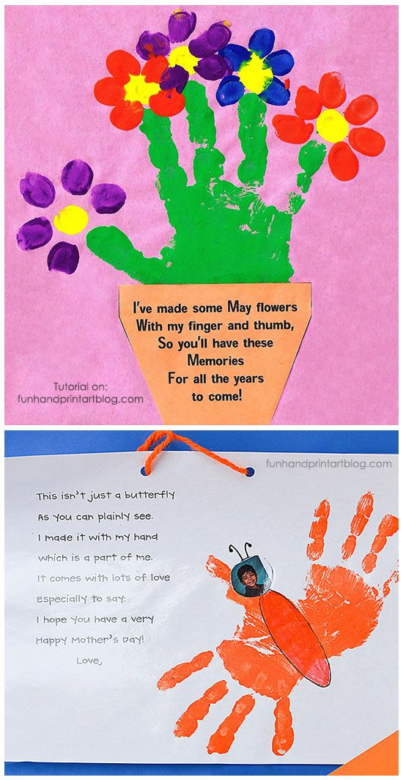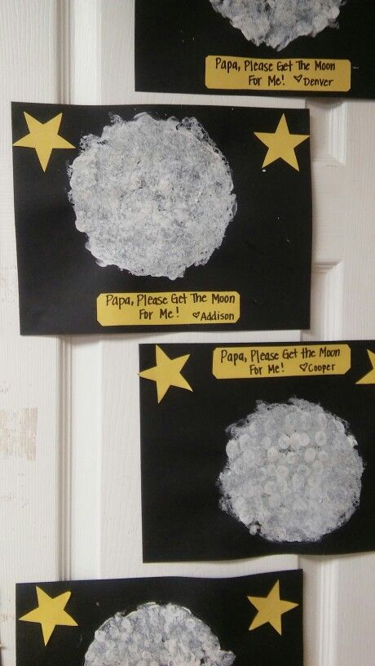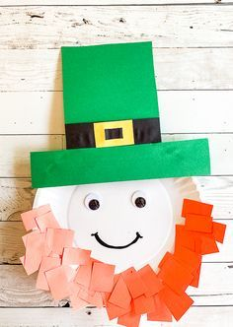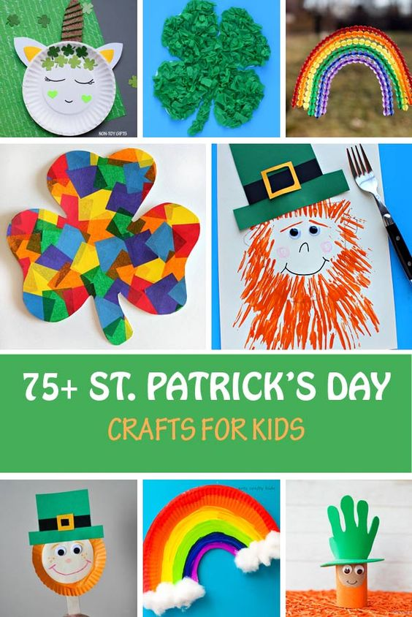 M

|  |  |  |  |
| --- | --- | --- | --- |
| **Stars in the Sky**  Sung to the tune of Itsy, Bitsy, Spider  See the shining stars(Hold up shiny side of star facing out)  Up in the big, night sky.  Look at them all twinkling  and blinking way up high!  When the morning comes, (Slowly start turning the star around)  the night turns into day  And the little twinkling stars. (Show plain side of star only.)  All seem to go away! | **Outer Space Poem**  I look up from Earth and try to see.  The planets looking back at me.  I gaze at bright and distant stars.  And search for Mercury, Venus and Mars.  I squint at the Milky Way, way up high.  And look for Jupiter in the sky.  Where are Saturn, Uranus, Neptune?  They're far away, high like the moon.  A telescope would be the best.  for spotting Pluto and the rest.  But even with my two eyes.  I look for planets in the sky. | **Planet song (You tube)** | **Thunderstorm poem**  Boom. Bang. Boom. Bang  Rumpety, lumpety, bump.  Zoom. Zam. Zoom. Zam.  Clipperty, clapperty, clump.  Rustles and bustles, and swishes and zings.  What wonderful noises a thunderstorm brings. |