Next step: - Place objects in, on and under on request.( CL, Understanding) ZC/YL

- Point to picture of common objects described by it use ( CL, Understanding)

Spoon and forks pouring and transferring sand play

Filling and eptying legos in water tray

(Being willing to have a go)

Musical instruments/ Noisy play Soldiers (Playing and exploring)

(circle time/ Monday to Friday)

One to one reading (Listening and attention )

Blocks play

Hide and seek a sound (Listening and attention) AG/Ks/JJ

Posting boxes (building sentences) Ks/ IK

**C&L**

**PSED**

**Week 07/06 & 14/06**

**Shapes, shapes are everywhere / Eid El Adha**

**Venus /Pluto**

**Shaped Bubble wrap painting (** (Monday1)

Playdough with shapes cutters (Tuesday 1)

Shape Garland (Wednesday 1)

Choo Choo train shape collage (Thursday 1)

Block painting (Monday 2)

**Eid el Adha cards (**Tuesday 2)

Sponge painting (Wednesday 2)

Easel water painting /Playdough (Thursday 2)

Junk modelling (Friday 1,2)

**PD**

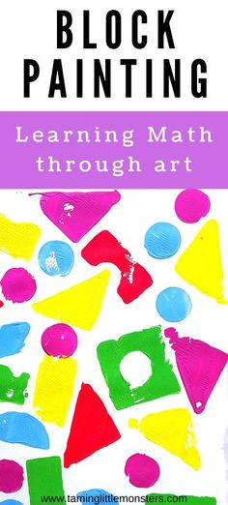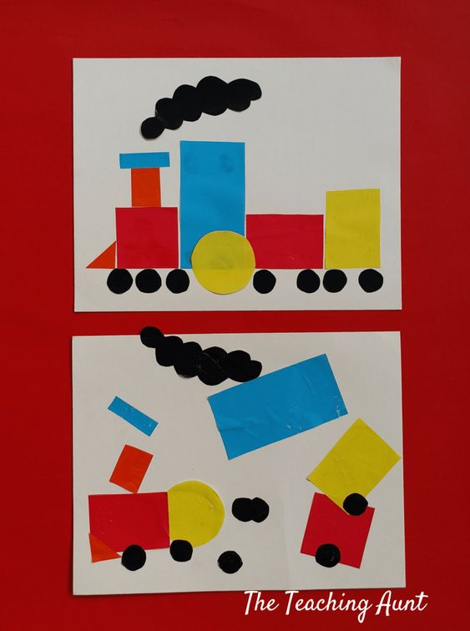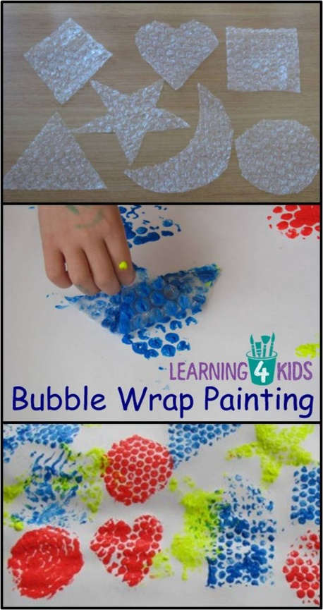Shape Garland (children to paint

different colours pre-cut shapes)

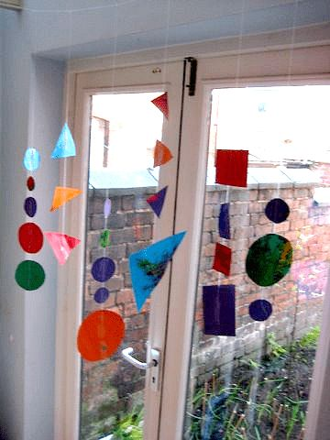

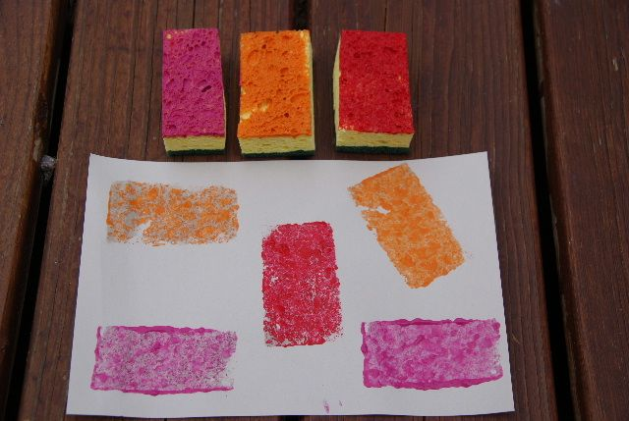

**Hide and seek a sound**: (Listening and attention)

**Implement**: choose a favourite musical toy, or use an alarm cock (start with a toy that makes a loud noise and move on to a toy with a quitter sound)

Hide the toy in a fairly obvious place in the room. Encourage the child to find the toy by listening to its noise.

Say “ Listen, can you hear the noise?” “Where Is it?”

Play it a different way: Hide yourself in the room with the toy. Star the noise of the toy and ask the child to come in and find you and the noise toy. (two adults needed for this)

**Intent** : Attention and listening to sounds to be able to recognise voice, speech sounds and early words before they can understand the meaning.

**Posting boxes:**

**Implement:** You will need a card box with a hole cut out of it, that you can post pictures or objects through.

Lay all the objects out and ask the infant/ toddler “which one shall we post?” They need to tll you which one can be posted before it goes in.

If the child is pointing rather than using word , give them a choice “shall we post the telephone or the cup?”

Make a big fuss when the object is posted, “look its gone! “ We posted the cup”

Intent: being able to put words together, get their message across more easily / reduce frustration communicate wants and needs.

|  |  |  |  |
| --- | --- | --- | --- |
| **If You’re Holding** (sung to If You’re Happy and You Know It)  Before singing, give each child a 2D pattern block to hold.  If you’re holding a square stand up! If you’re holding a square stand up! If you’re holding a square, if you’re holding a square If you’re holding a square stand up.  Repeat with other shapes | Shapes Song  (Sung to Frère Jacques)  This is a circle, this is a circle,  How can you tell? How can you tell?  It goes round and round,  No end can be found,  It’s a circle, it’s a circle. | The Square Shape Song  (Sung to Twinkle Twinkle Little Star)  Put your square shape in the air,  Hold it high and keep it there.  Put your square shape on your back,  Now please lay it on your lap.  Put your square shape on your toes,  Now please hold it by your nose.  Hold your square shape in your hand,  Now will everyone please stand.  Wave your square shape at the door,  Now please lay it on the floor.  Hold your square shape and jump, jump, jump,  Now throw your square shape way, way up. | *Books*  *Brown Paper bear*  *Holiday Shapes*  *PB Bear's Shapes*  *Soft Shapes*  *Spot's Big Book of Colours,* |

.