Sunnyfields Newsletter
July 2021

Welcome
Welcome to Ella Brown, Reggie Sauerbach, Nakshatra Vegunta, Ivy & Neve Blue, Aayu Rachakonda, Radhya Singh Bhadoriya,Rory Sharpe, Vincent Vansanden, Zale Mather, Olivia Sun, Lorien James, who have joined us recently. We hope that you all have lots of fun whilst you are at Sunnyfields.
Recent Topics
Since our last newsletter in May the children have enjoyed the following topics and activities.
‘Occupations & What Jobs People Do’. - The children explored the many different jobs that people do, they got to learn about being teachers, builders and various emergency service workers. We discovered and created our own means of transport that we thought these occupations used. We even got to see jobs that are not as popular for example we made our home corner into to lab so we could become entomologists. We saw some exciting messy tuff trays with various construction materials, one of the popular tuff trays was barn on fire book themed with fire engines and other props to enable the children to put fires out. Within our younger rooms we got to explore the colours and sounds of occupations, police cars seemed very popular alongside this the younger children showed their caring side by becoming nurses and doctors.
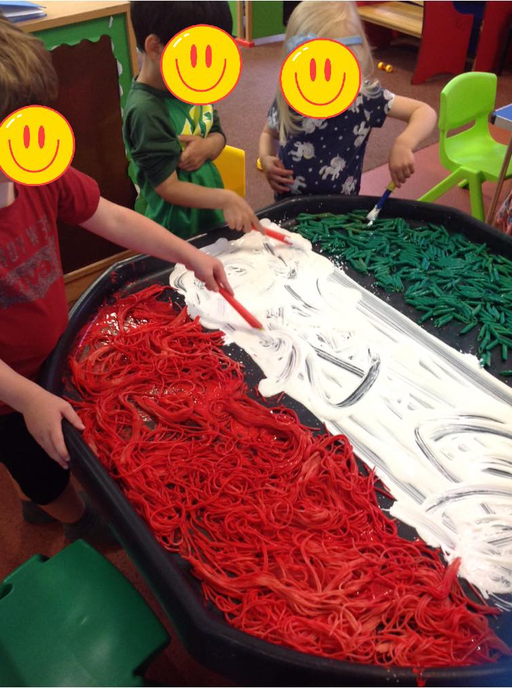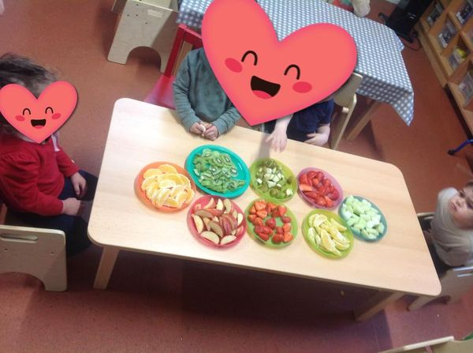
‘Sports’ - Within our sports topic we looked at a variety of different sports including the Euros 2020. We held mini sports days and challenges through sport. The children got to explore many different sports themed activities, especially through stories and expressive arts and design. In the Preschool room we looked at making flags and medals, we also discussed physical effects on our bodies. Within the Baby room did mark making for our football pitch board. We also looked healthy snacks and why it’s very important to eat well!
Within the last few months, we have celebrated our Sponsored walk for Demelza, Ramadan, The Queen’s birthday, and Father’s Day we also achieved 30 days wild for the whole of June!
Our most recent topic is ‘Journeys’ - The children have been exploring the ways we travel using different types of transport and the different journeys we see in our lives. We discussed and looked at the details of how things work and why they work, including destination and climates of different countries. Baby Room has been doing a lot of sensory looking at types of weather. We’re continuing this theme and have some very exciting activities and learning opportunities coming up so keep an eye on our Facebook page and Tapestry
Our next theme is ‘Science’ - we have lots of exciting activities planned, so keep an eye on Facebook and of course Tapestry for updates. If any parents/carers would like to arrange a time to visit with the children to talk about the job they do, please speak to Loren or Sarah.
Learning at home with parents
Ideas to try with your children at home relating to our forthcoming topic. During May and June, we are exploring; the colours grey and yellow, ‘the jobs people do’, different ‘sports’ and ‘ways to travel’. We are discussing and talking about ‘being safe and keeping ourselves safe’.
- Play doctors/ nurses/ vets/ baby clinic at home with toys and dolls.
- Use a box (cardboard or plastic) to make into a bus and the ‘bus driver’ can transport the toys to their destinations, similarly, create a fire engine for the ‘fire fighter’ to rescue the toys, or a police car that can drive fast.
- If you have any books to read at home on people who help us or can access online books to share at home
- Make a space for a toddler/ child office, toy phone/ iPad etc with paper and pencils.
- Dress your little one as a chef and make some yummy smoothies/ fruit salad/ soup and cut the fruit and vegetables together.
- Go on a grey and yellow treasure hunt around the house, how many grey things can you find and likewise yellow items.
- Mix paint to create grey or what happens to different colours when you add yellow.
- Go on a walk and find the numbers on houses, car number plates, look for one cat, two birds etc.
If you are celebrating a festival over the forth coming weeks, please share photos/ items to show, so we can celebrate with you at nursery.

Staffing
Since our last Newsletter we have sadly had to say “goodbye” to Emily who has left to further her career elsewhere. We have welcomed Abbigail who will be joining our preschool team alongside Sarah and Fahmida as an apprentice. We have also welcomed Shevonne, who joins us as a level 3 Qualified Nursery Nurse within our preschool room.

Progress Report
Progress reports were sent out on Wednesday 30th June 2021 we hope you have received these and are happy with the reports. If any parents would like to share a “WOW” moment please email or text them into us via the nursery mobile or email. Our next zoom report week will be week commencing Monday 27th September 2021 .

Feedback
As always, we appreciate the lovely comments that you wish to share with us which, in turn, we will pass on to future families looking for childcare. You can do this via the feedback form, or the suggestion box in the entrance hall, or via email to head office, or with a letter or note, on our Facebook page, on Google review and on the Day nurseries site.

Labelling of clothes / Toys from home
We have seen an increase in clothes not being labelled. Can we remind parents to please label all of your child’s clothing, this will reduce the loss of children’s clothes. Can we please ask that toys from home not be bought into nursery as we cannot take responsibility for the loss or damage to toys.

Appropriate outer wear
With the weather starting to get a little bit warmer, could I remind you all to update the children’s bags and ensure that they have appropriate outerwear, this includes summer hats. Alongside this can we remind parents to apply an 8-hour sun lotion before attending nursery.

Sunny’s Gardening Community
We will be launching our very own garden club within our wonderful veggie patch. It will be a great opportunity for parents to get to know each other and of course get green fingered growing and contributing to some lovely home-grown food! This will be launching from August 2021! The first day being Friday 13th August 2021 10-10:45am. We will be sending out a text and leaflets will be displayed on our entrance.

Dates for your diary
- Monday 27th September -Friday 1st October 2021 Zoom Report week
- Week commencing 4th October Harvest festival celebrations
More information on all these events will be displayed on the front door of the nursery nearer the time.

Kind Regards,
Loren Williams and the Team.

