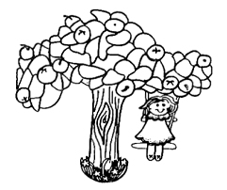
Withdrawal Form

This form must be used by parents who intend to withdraw their child from the Orchard Pre-school. The following rules apply:
- One half term’s notice is required for the withdrawal of a child.
- Notice must be given to the Supervisor in writing (a signed and dated copy of this form may be used for the purpose).
- If notice is not received you will be liable for the equivalent of one half term’s fees plus loss of your £40 deposit.

I hereby give notice that I wish to withdraw my child from the Orchard Pre-school.
Child’s name:…………………………………………………………………………………………….......
Effective date of withdrawal: ……………………………………………………………………………….
Parent’s signature:……………………………………………..... Date:…………………………............
Parent’s name (block): ………………………………………………………………………………………
Parents who give due notice for the withdrawal of a child will be eligible for return of their £40 deposit in the form of a cheque.
Cheque to be made out to (name): ……………………………………………………………………….
Address to which cheque may be sent: …………………………………………………………………..
………………………………………………………………….………………………………………………
Alternatively, please tick here if you wish to donate your £40 deposit to the Orchard Pre-school to benefit general funds

For Office use:
Date form received:………………………….......... Sufficient notice given? Yes / No
Supervisor’s signature: …………………………… Supervisor’s name (block): …………………………….

