Home learning activities

Masking tape track

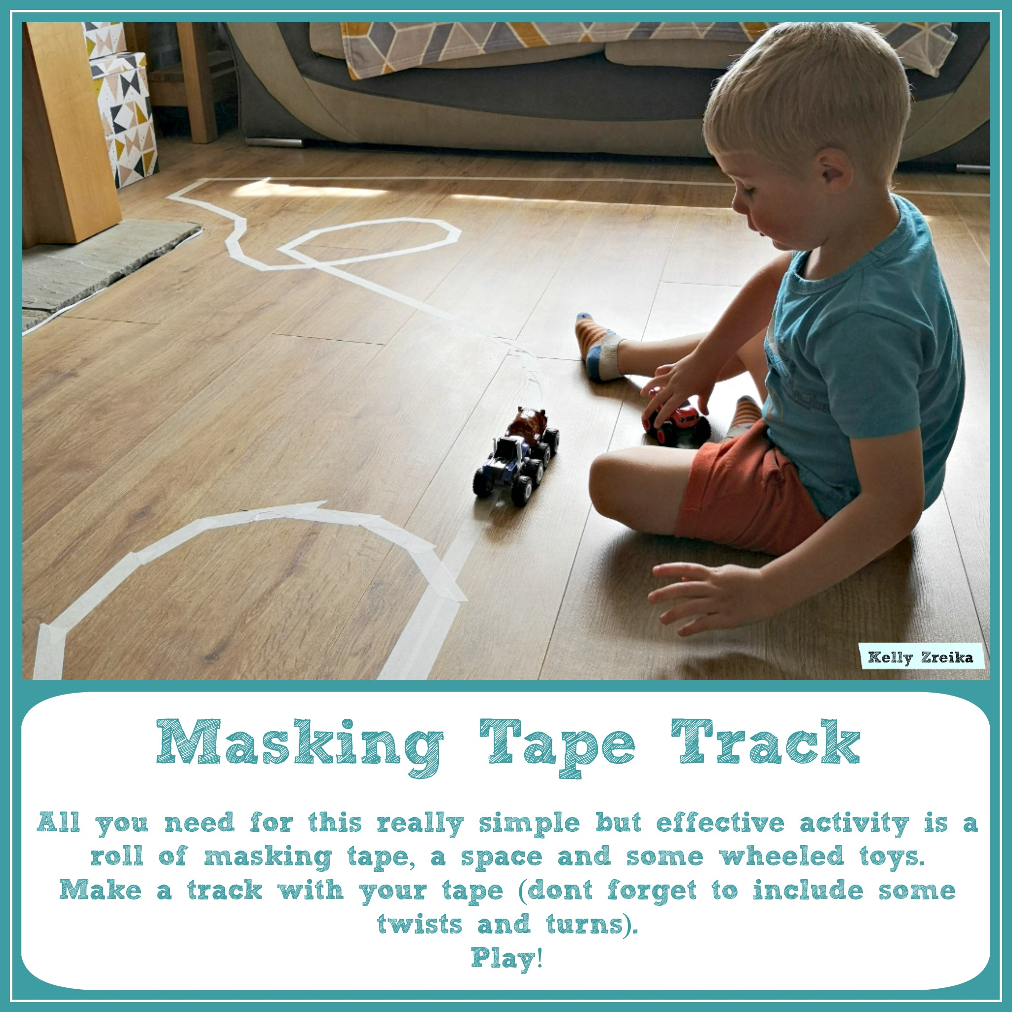All you need for this really simple effective activity is a roll of masking tape, a space for some wheeled toys.

Make a track with your tape (don’t forget to include some twists and turns).

To extend this activity you could add objects such as a cardboard box to make a garage or a ramp.

Talk about the different vehicles the children have, what they do and where they see them.