Home learning activities

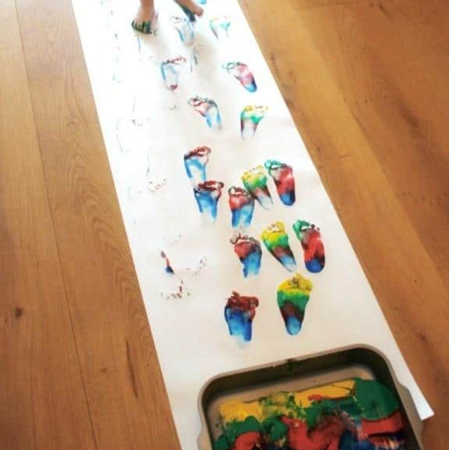Rainbow feet painting

Fill up a tray of a variety of different colours.

Roll out a long roll of paper and encourage your children to create rainbow footprints.

You can talk about the colours, the number of footprints that are being made. You could talk about the different body parts and extend this by using hands or fingers to create marks.

You could then create this into a picture and treasure the memories for life ☺