Home learning activities

Spoon friends

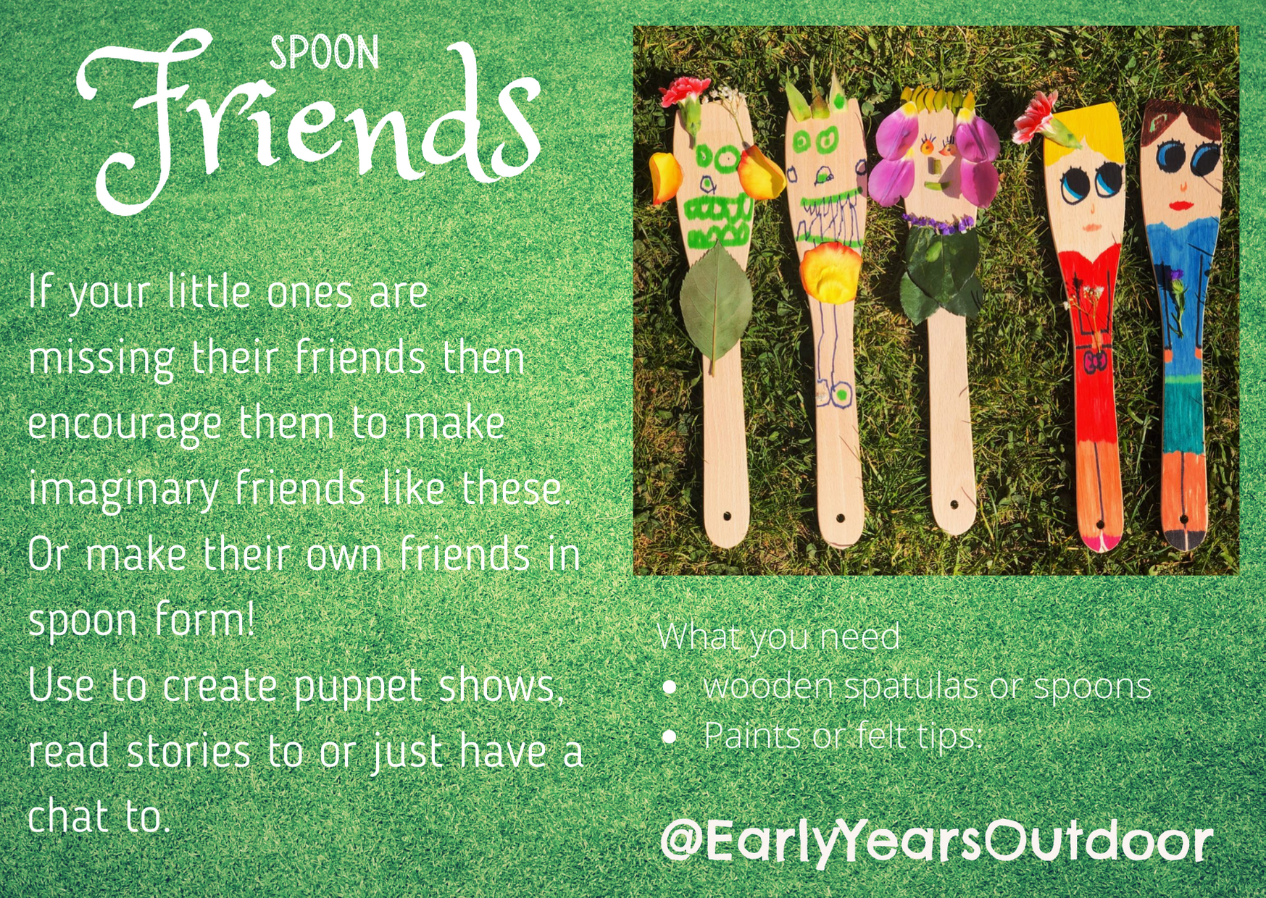

Create spoon friends with your children. This will then encourage the children to show curiosity and use their imagination whilst creating their spoon friend.

This could be extended by creating a puppet show, singing nursery rhymes or telling imagination stories.

This is a lovely way to build your children’s confidence up in big or small groups.