Home learning activities

The tray game

How to play:

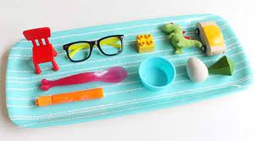

* You will need a tray and a cloth
* Put a certain number of objects on a tray
* Encourage the children to have a look at what they can see on the tray
* Then get the children to close their eyes while you cover it over with the cloth
* Once covered see if the children can recall what was on the tray and list the objects to you without peeking