Home learning activities

What’s in the story telling tin?

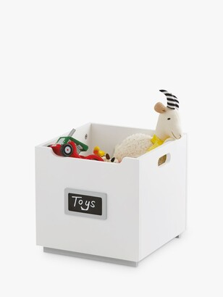What you need:

* An empty tin, container or box
* Gather loose parts or small world toys – create a theme to make a story.

Before opening the container – ask the children open ended questions such as what do you think will be inside?

Encourage the children to create a story from the objects you have put into the tin and extend on the story they are telling you.