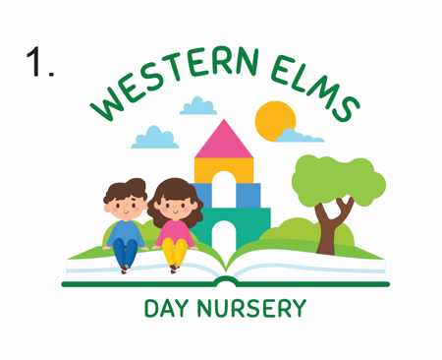

10/03/2023

Dear Parents/ Carers

Staff changes

I would like to address that Western Elms will be having some staff changes in the rooms to benefit the nursery as a whole.

Hollie will be leaving Western Elms nursery to widen her experience in the nursery field. Hollie has been with us since she has left school. We would like to wish her all the best in her new adventures.

We have a member of staff joining us Freya. Freya is a Level 3 Qualified and will take over from Hollie and run our Ladybird room. Freya has had over 5 years’ experience working in the Toddler room and is really excited to start with us at Western Elms. Freya will be starting with us on Tuesday 11th April 2023.

Tayla who works in the Ladybird room will be going on maternity leave, her last day with us is on Friday 21st April 2023. We would like to wish Tayla all the best with her new baby boy!

Emily who is currently in the Grasshopper room as a room leader, will be moving to the Bumblebee room as their room leader. Emily will move on the 17th April 2023.

Jessica who currently works in our Bumblebee room will be moving to our Ladybirds room. Jessica will be moving on the 27th March.

Bumblebees
Emily- Room leader and Level 3 Qualified
Kayleigh – Level 3 Qualified
Keira – Level 3 trainee
Ria – Level 3 trainee

Ladybirds
Freya- Room leader and Level 3 Qualified
Tayla – Level 3 Qualified
Laura – Level 2 trainee

Grasshoppers
Donna – Assistant Manager/ Room leader and Level 3 Qualified
Ellie – Level 2 trainee

Due to these changes, there will be individual letters to any key person changes that will be happening within the nursery.
If you have any questions, please do not hesitate to ask.

Yours sincerely,
Megan and Jean
Nursery Manager and Nursery owner

