Home learning activities

Shape hunt

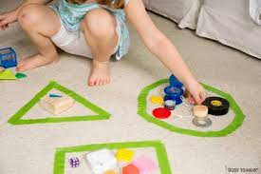Create two areas where the children can put the different shapes they find. Take them on a shape hunt, this could be in the garden, indoors or even on a day out.

Hide objects of the same shapes around and encourage the children to sort them out into the right area and collect the right shape for their hunt.

Have fun!