Westwards Nursery Presents a Summer Carnival
On Saturday the 25th June 10am -12.30pm All welcome!

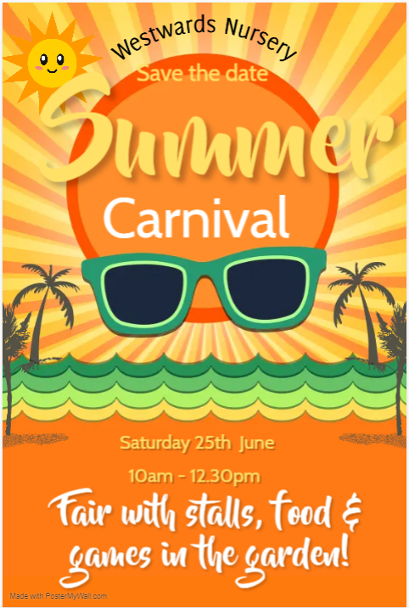

There will be lots of games to play and lots of fun to be had by all!
Please fill in the slip below and return to a member of staff in order to receive your ticket. Each ticket costs 50p per child. Please remember to bring it with you to exchange for a Carnival chocolate!

Hook a duck – sweets in a jar – lucky dip - cake stall – arts and crafts –guess the Unicorn name - face painting - raffle – refreshments and food!
------------------------------------------------------------------------------

Name of Child/Family name____________________________

I would like ________ tickets for the Carnival Chocolate Hunt. Please find enclosed _________.

I am able to donate cakes for the cake stall – Yes/no
I am able to donate prizes for the raffle/tombola – Yes/no
I would like to order the following food – meat/veg hotdog (£1.50), veg samosa (£1), margherita pizza slice (£1). Please indicate what you would like to order with quantities. You can also pay on the day.
_______________________________________________

Money raised will go towards charity (TBC). Thank you! Westwards Team

